

Project 1

Fall 2020 CSCI 331 DATABASE SYSTEMS

GROUP 1

CLASS TIME:10:45

Trisha Espejo

Professor Peter Heller

Table of Contents

Simple Problem 1 1

Key View: Error! Bookmark not defined.

Standard View: 2

Code: 2

JSON Path: 3

Result Table: 4

Required Table: 4

Simple Problem 2 5

Key View: 5

Standard View: 5

CODE: 6

JSON Path: 7

Result Table: 8

Required Table: 8

Simple Problem 3 9

Key View: 9

Standard View: 9

Code: 10

JSON Path: 10

Result Table: 11

Required Table: 11

Simple Problem 4 12

Key View: 12

Standard View: 12

Code: 13

JSON Path: 14

Result Table: 15

Required Table: 15

Simple Problem 5 16

Key View: 16

Standard View: 17

CODE: 17

JSON Path: 18

Result Table: 19

Required Table: 19

Medium Problem 1 20

Key View: 20

Standard View: 21

Code: 21

JSON Path: 22

Result Table: 23

Required Table: 23

Medium Problem 2 24

Key View: 24

Standard View: 24

Code: 25

JSON Path: 25

Result Table: 26

Table Required: 26

Medium Problem 3 27

Key View: 27

Standard View: 27

Code: 28

JSON Path: 28

Result Table: 29

Table Required: 29

Medium Problem 4 30

Key View: 30

Standard View: 30

Code: 31

JSON Path: 32

Result Table: 33

Required Table: 33

Medium Problem 5 34

Key View: 34

Standard View: 34

Code: 35

JSON Path: 36

Required Table: 37

Table Required: 37

Medium Problem 6 38

Key View: 38

Standard View: 39

Code: 39

JSON Path: 40

Result Table: 41

Required Table: 41

Medium Problem 7 42

Key View: 42

Standard View: 43

Code: 43

JSON Path: 44

Result Table: 45

Table Required: 45

Medium Problem 8 46

Key View: 46

Standard View: 46

Code: 47

JSON Path: 48

Result Table: 49

Required Table: 49

Complex Problem 1 50

Key View: 50

Standard View: 51

Code: 52

JSON Path: 53

Result Table: 54

Complex Problem 2 55

Key View: 55

Standard View: 56

Code: 57

JSON Path: 58

Result Table: 59

Required Table: 59

Complex Problem 3 60

Key View: 60

Standard View: 61

Code: 62

JSON Path: 63

Result Table: 64

Required Table: 64

Complex Problem 4 65

Key View: 65

Standard View: 66

Code: 67

JSON Path: 68

Result Table: 68

Required Table: 68

Complex Problem 5 69

Key View: 69

Standard View: 70

Code: 71

JSON Path: 72

Result Table: 73

Required Table: 73

Complex Problem 6 74

Key View: 74

Standard View: 75

Code: 76

JSON Path: 77

Result Table: 78

Required Table: 78

Complex Problem 7 79

Key View: 79

Standard View: 80

Code: 81

JSON Path: 82

Result Table: 83

Required Table: 83

# Simple Problem 1

**Proposition:** Return all customer and the product ordered in 2014

**Query Required:** Northwind2020

**Table Required:** Sales.Order, Sales.OrderDetail

**Problem Description:**

Create a query that return all customer that order in 2014. It list all district product id , orderdate, and cutomerid and query is Northwind2020. Ordered By product.

## Key View:

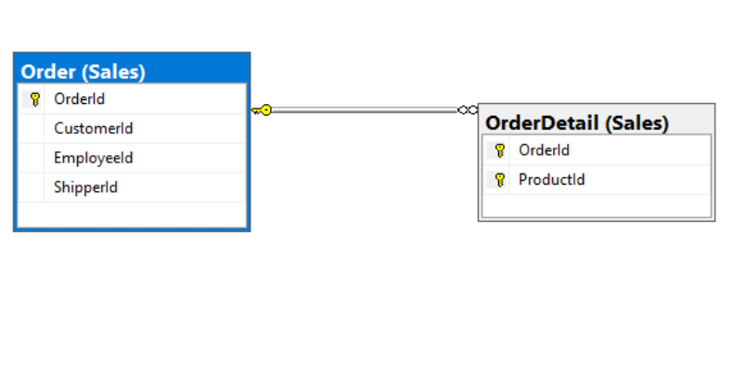

## Standard View:

## 

## Code:

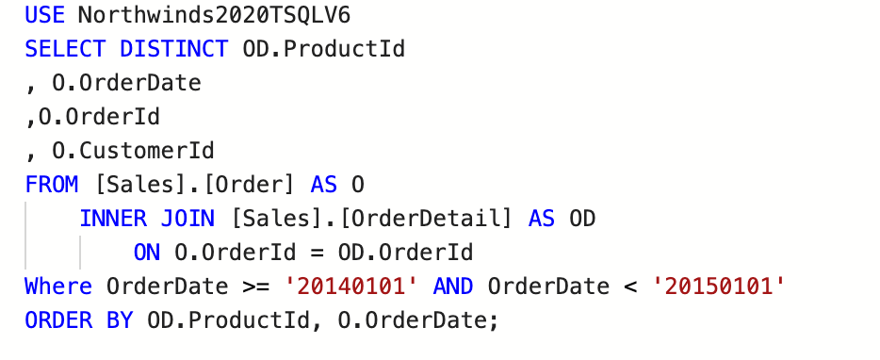

## 

## JSON Path:

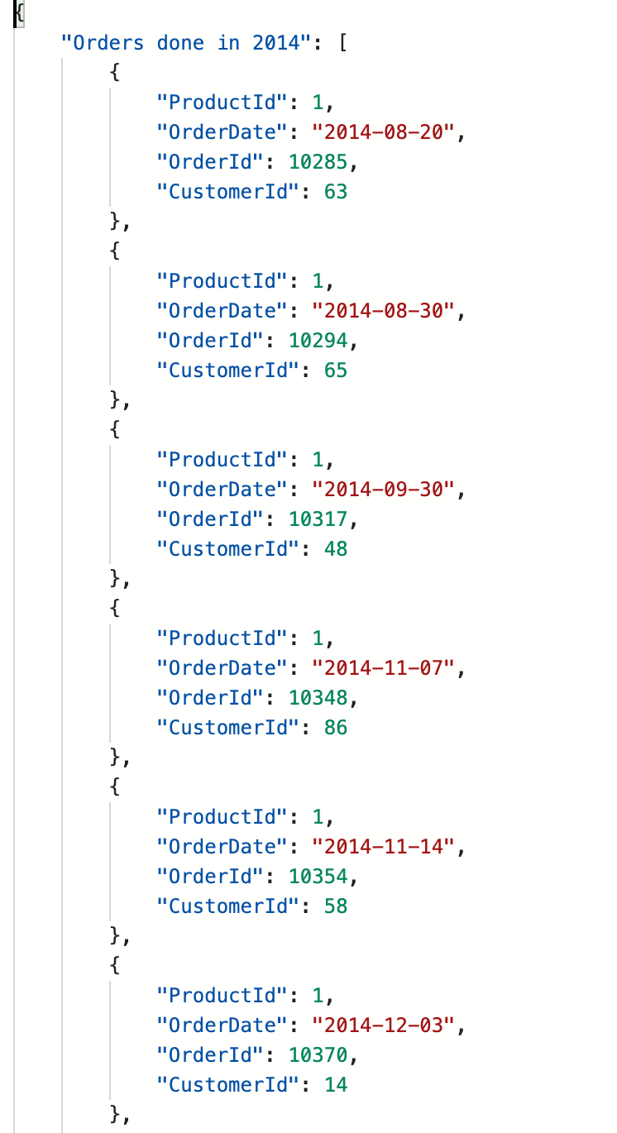

## 

## Result Table:

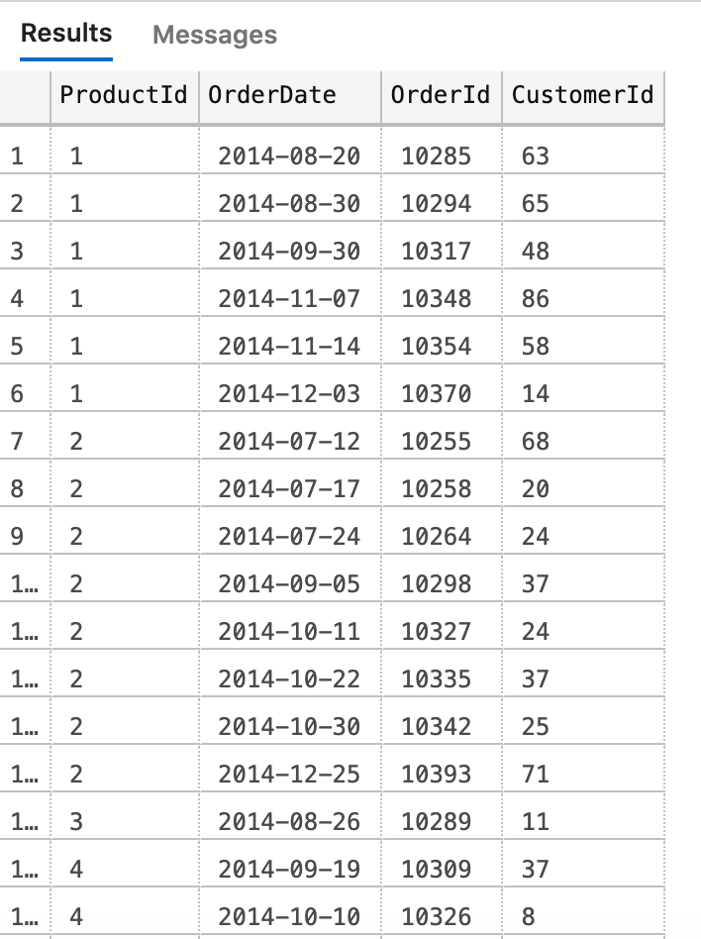

(405 rows affected)

## Required Table:

|  |  |
| --- | --- |
| Table Name | Column Name |
| Sales.Order | **Orderdate**  **OrderId**  **CustomerID** |
| Sales.OrderDetail | **ProductID** |

# Simple Problem 2

**Proposition:** Return all products who’s supplies came from Japan

**Query Required:** Northwind2020

**Table Required:** Product.Supplier, Production.Product

**Problem Description:**

In this problem you are looking for all supplies that came from Japan. . It list all supplier id, product name supplier company name and supplier city from Product Supplier table and query is Northwind2020.

## Key View:

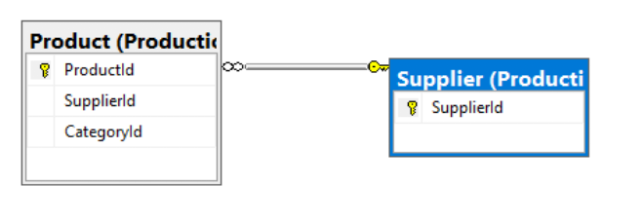

## Standard View:

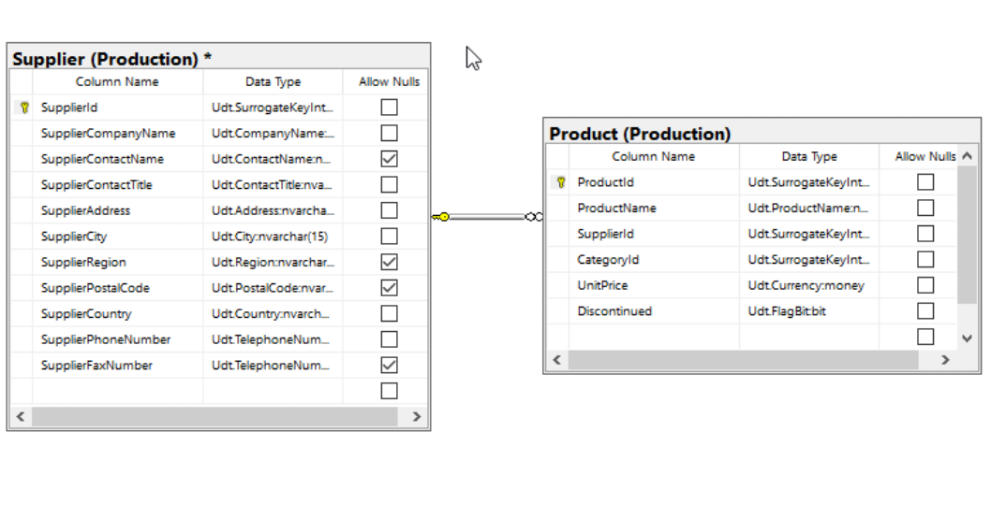

## 

## CODE:

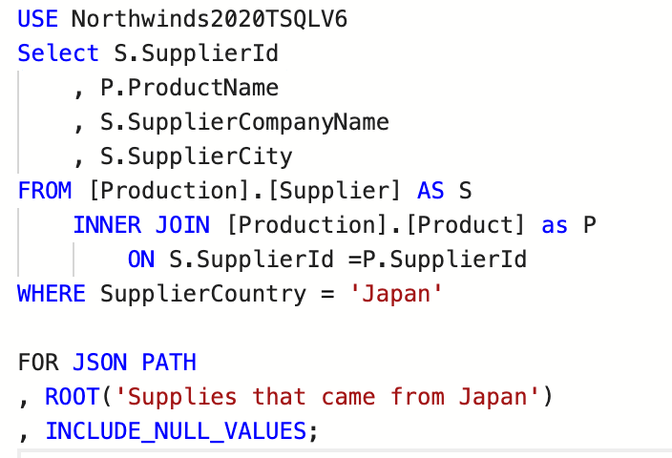

## 

## JSON Path:

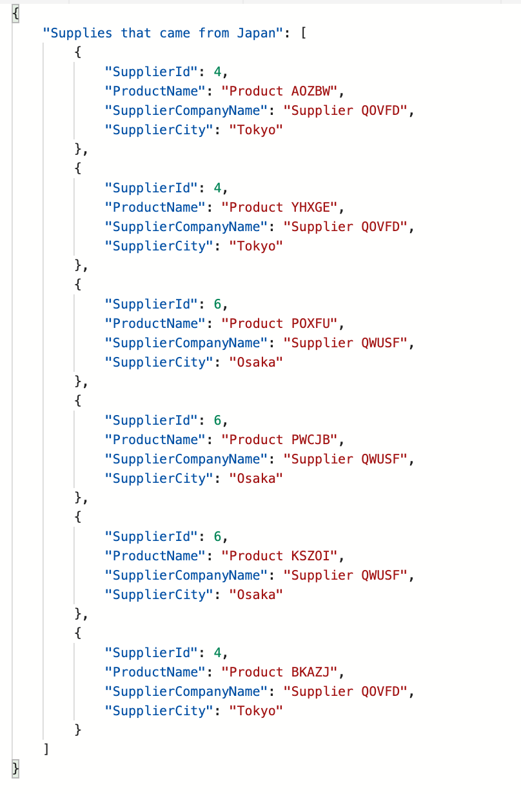

## Result Table:

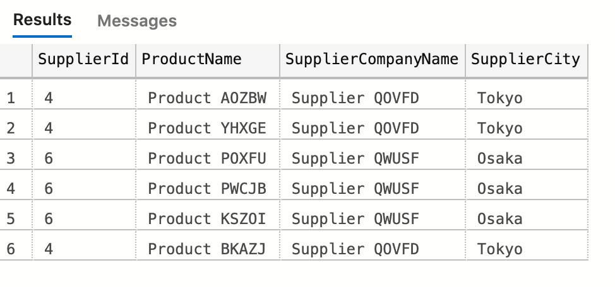

(6 rows affected)

## 

## Required Table:

|  |  |
| --- | --- |
| Table Name | Column Name |
| Production.Supplier | **supplierid**  **suppliercompanyname**  **suppliercity** |
| Production.Product | **ProductName** |

# 

# Simple Problem 3

**Proposition:** Return top 5 employees with the highest bonus

**Query Required:** AdventureWork2017

**Table Required:** Sales.SalesPerson, HumanResource.Employee

**Problem Description:** In this problem you are looking for top 5 employees with the highest bonus. It list all bonus , BusinessEntityID and their SalesQuota and gender of the top five employees. table and query is AdventureWorks2017

## 

## Key View:

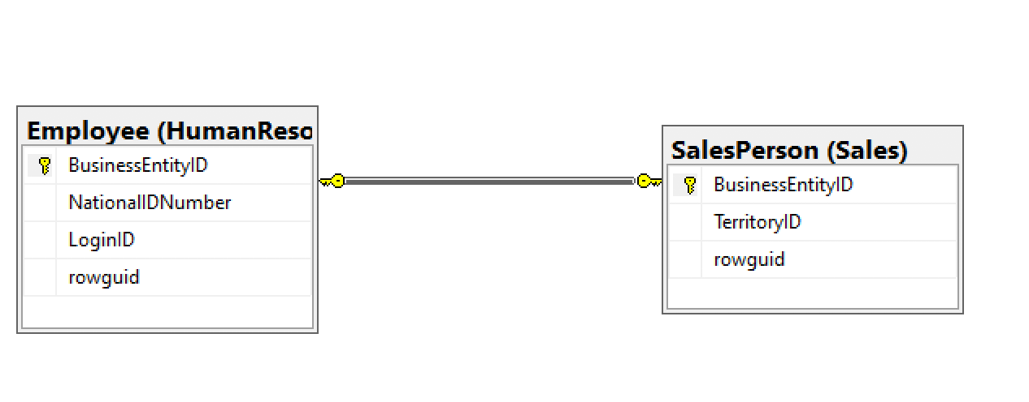

## Standard View:

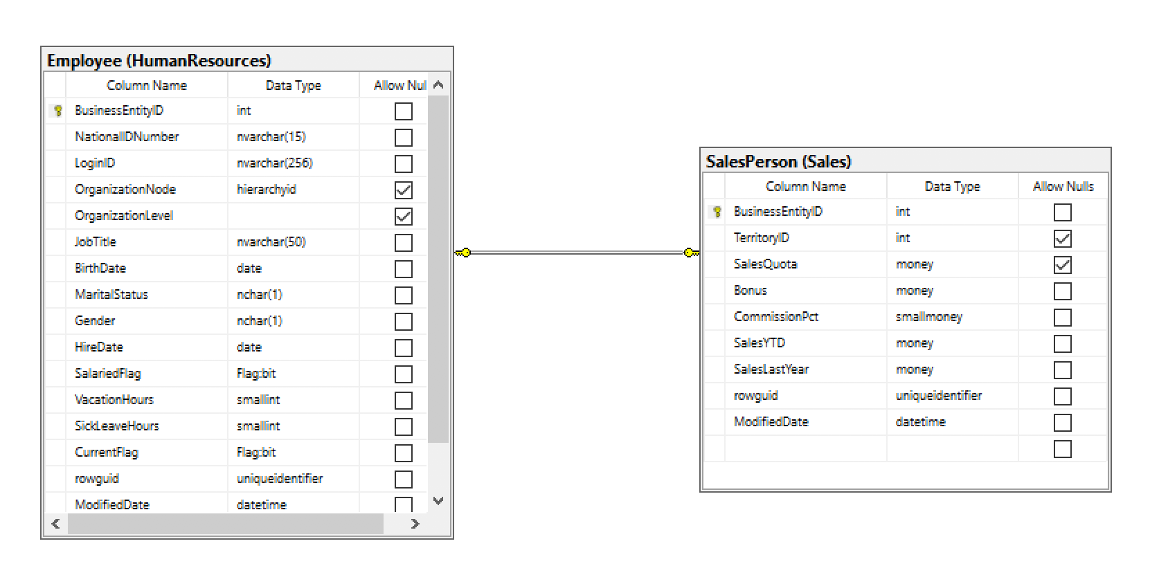

## Code:

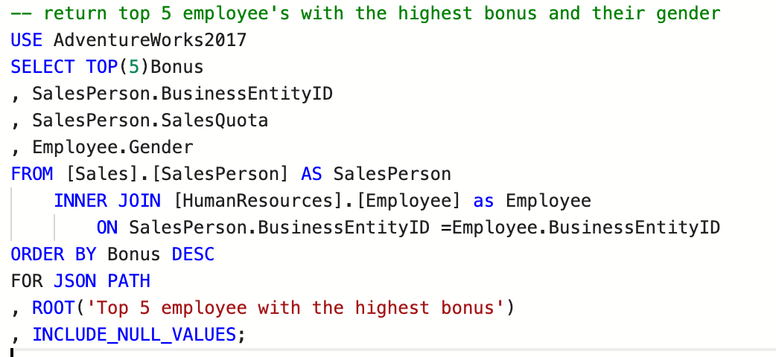

## JSON Path:

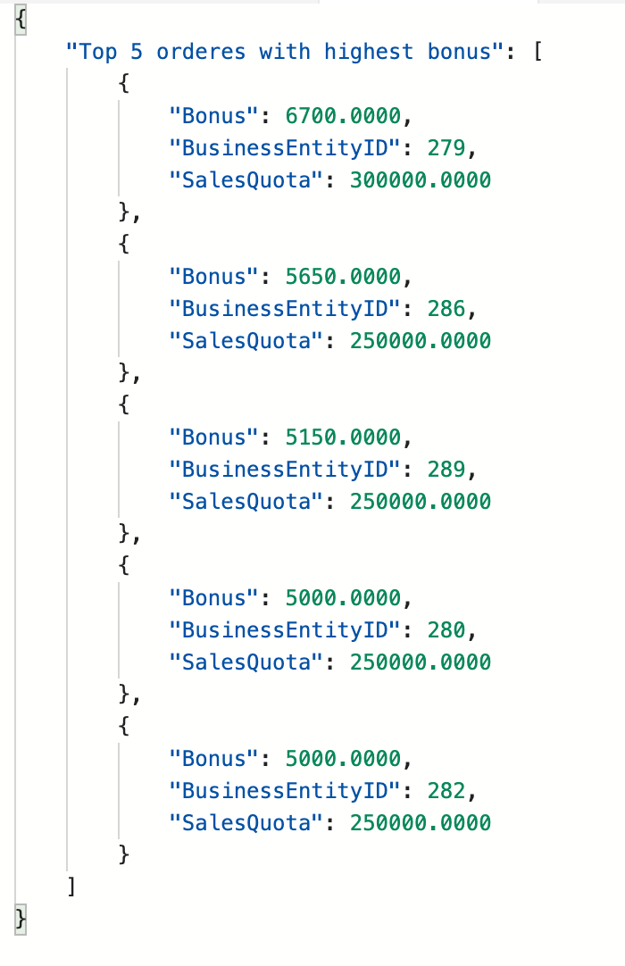

## Result Table:

## 

(5 rows affected)

## Required Table:

|  |  |
| --- | --- |
| Table Name | Column Name |
| Sales.SalesPerson | **Bonus**  **BusinessEntityID**  **SalesQuota** |
| HumanResource.Employee | **Gender** |

# Simple Problem 4

**Proposition:** return all human resource employee's with last name that begins with the letter "E" and list their first name last name and job title

**Query Required:** AdventureWork2017

**Table Required:** Person.Person, HumanResource.Employee

**Problem Description:**

Create a query under return all employee's with last name that begins with the letter "E" and list their first name. It list all person who’s last name begins with “E” last name and first name using AdventureWorks2017. Then order it by the employee’s last name.

## 

## Key View:

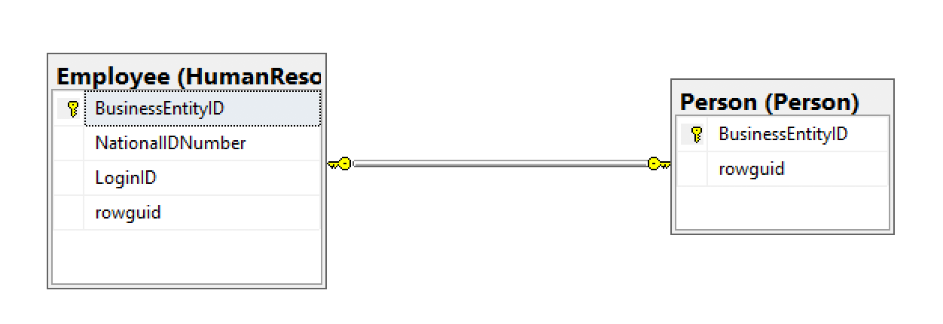

## Standard View:

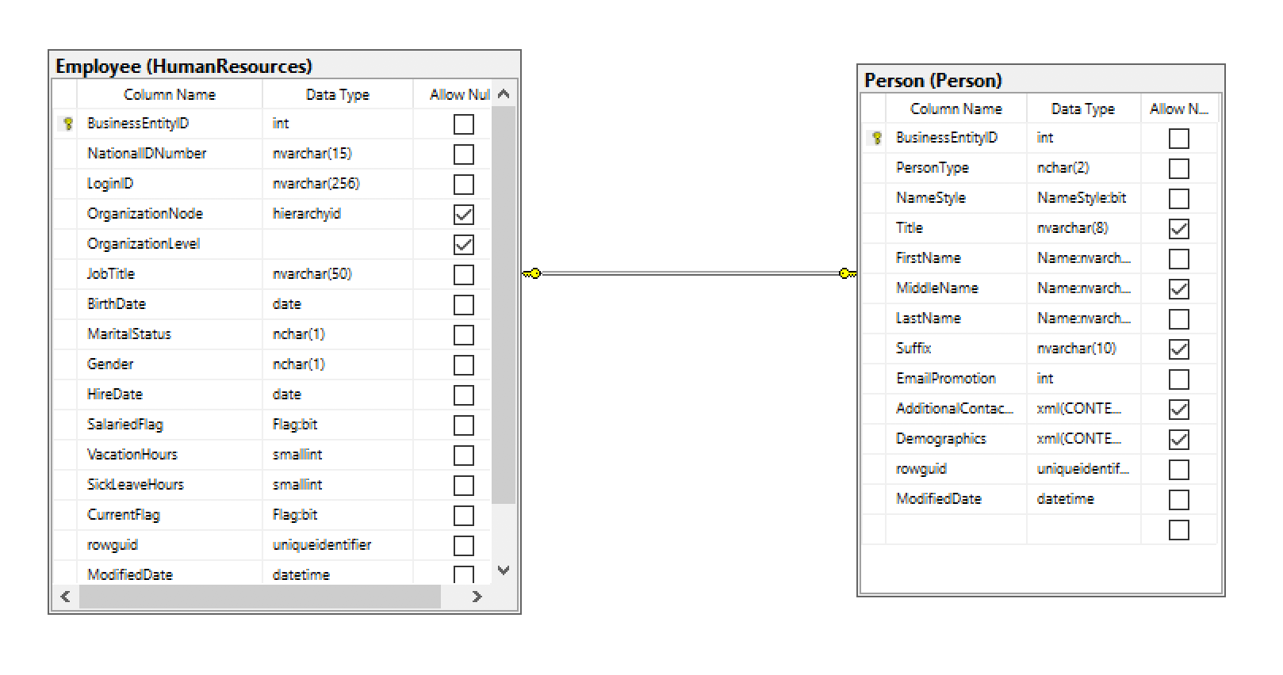

## Code:

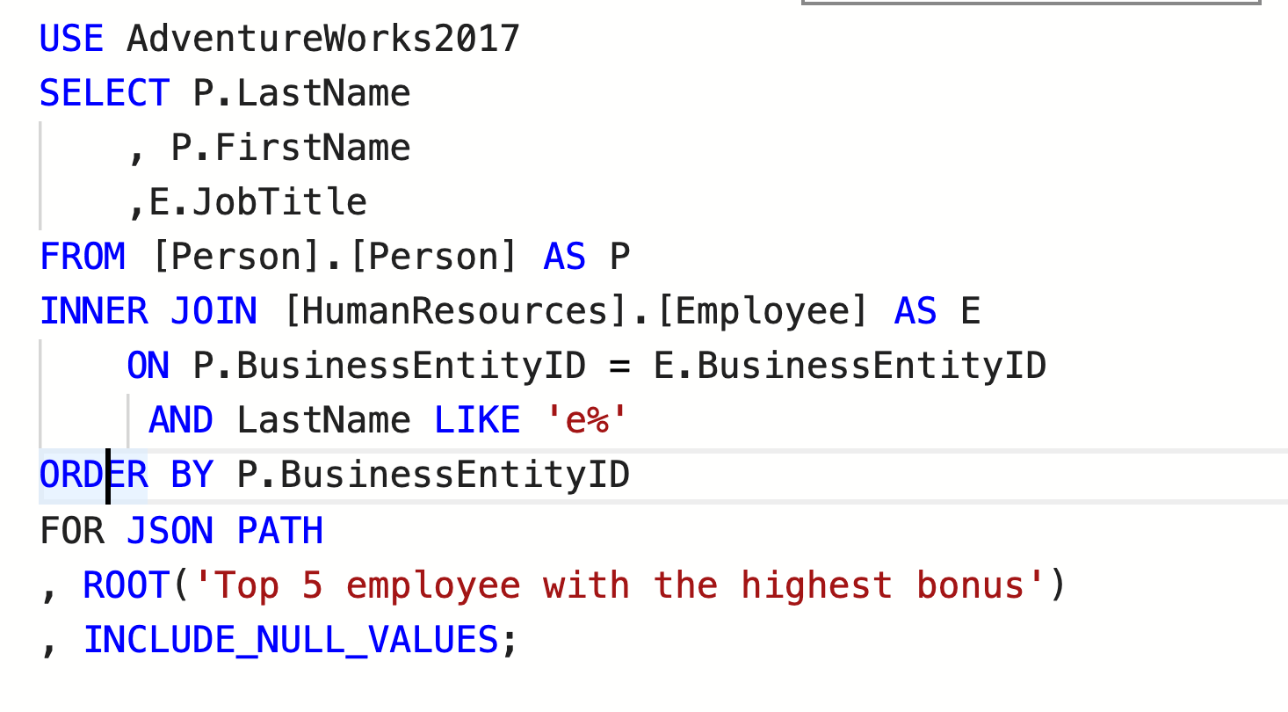

## JSON Path:

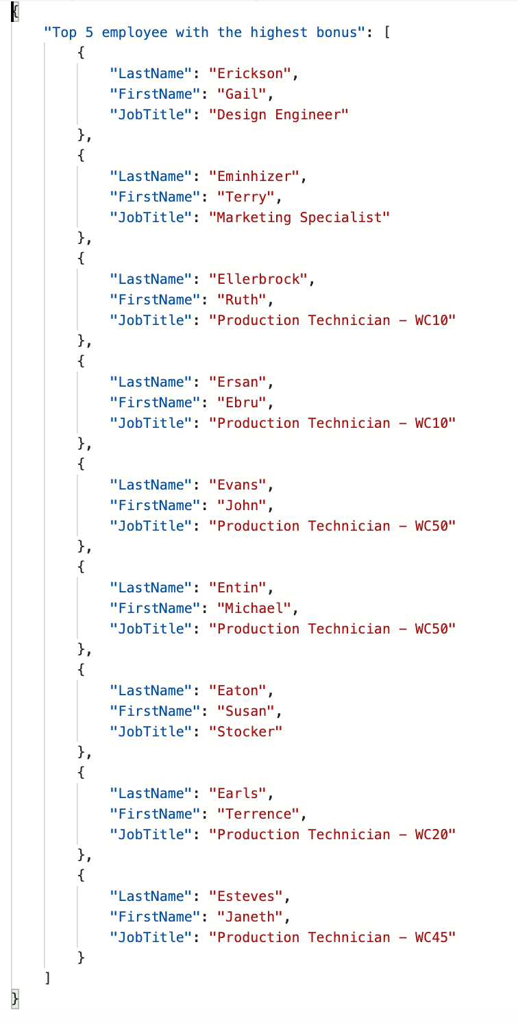

## Result Table:

## 

(9 rows affected)

## Required Table:

|  |  |
| --- | --- |
| Table Name | Column Name |
| Person.Person | **Lastname**  **FistName**  **BusinessEntityID** |
| HumanResource.Employee | **JobTitle** |

# 

# Simple Problem 5

**Proposition:** Return all of sales quota of employees from Q1

**Query Required:** AdventureWorkDW2017

**Table Required:** dbo.FactSalesQuota, dbo.dimEmployees

**Problem Description:**

Create a query that find all employees sale’s quota from quarter 1. List the employee’s full name which is written as lastname then first in one column, employee’s sales quota and calendar year using AdventureWorks2017.

## Key View:

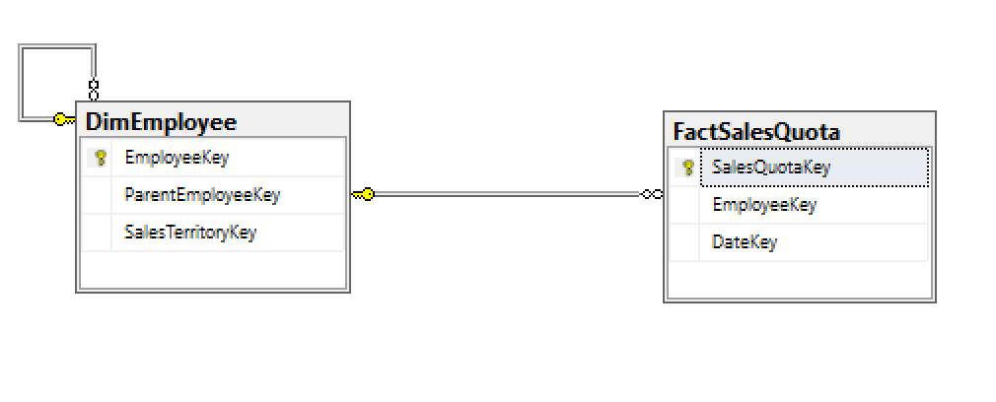

## 

## Standard View:

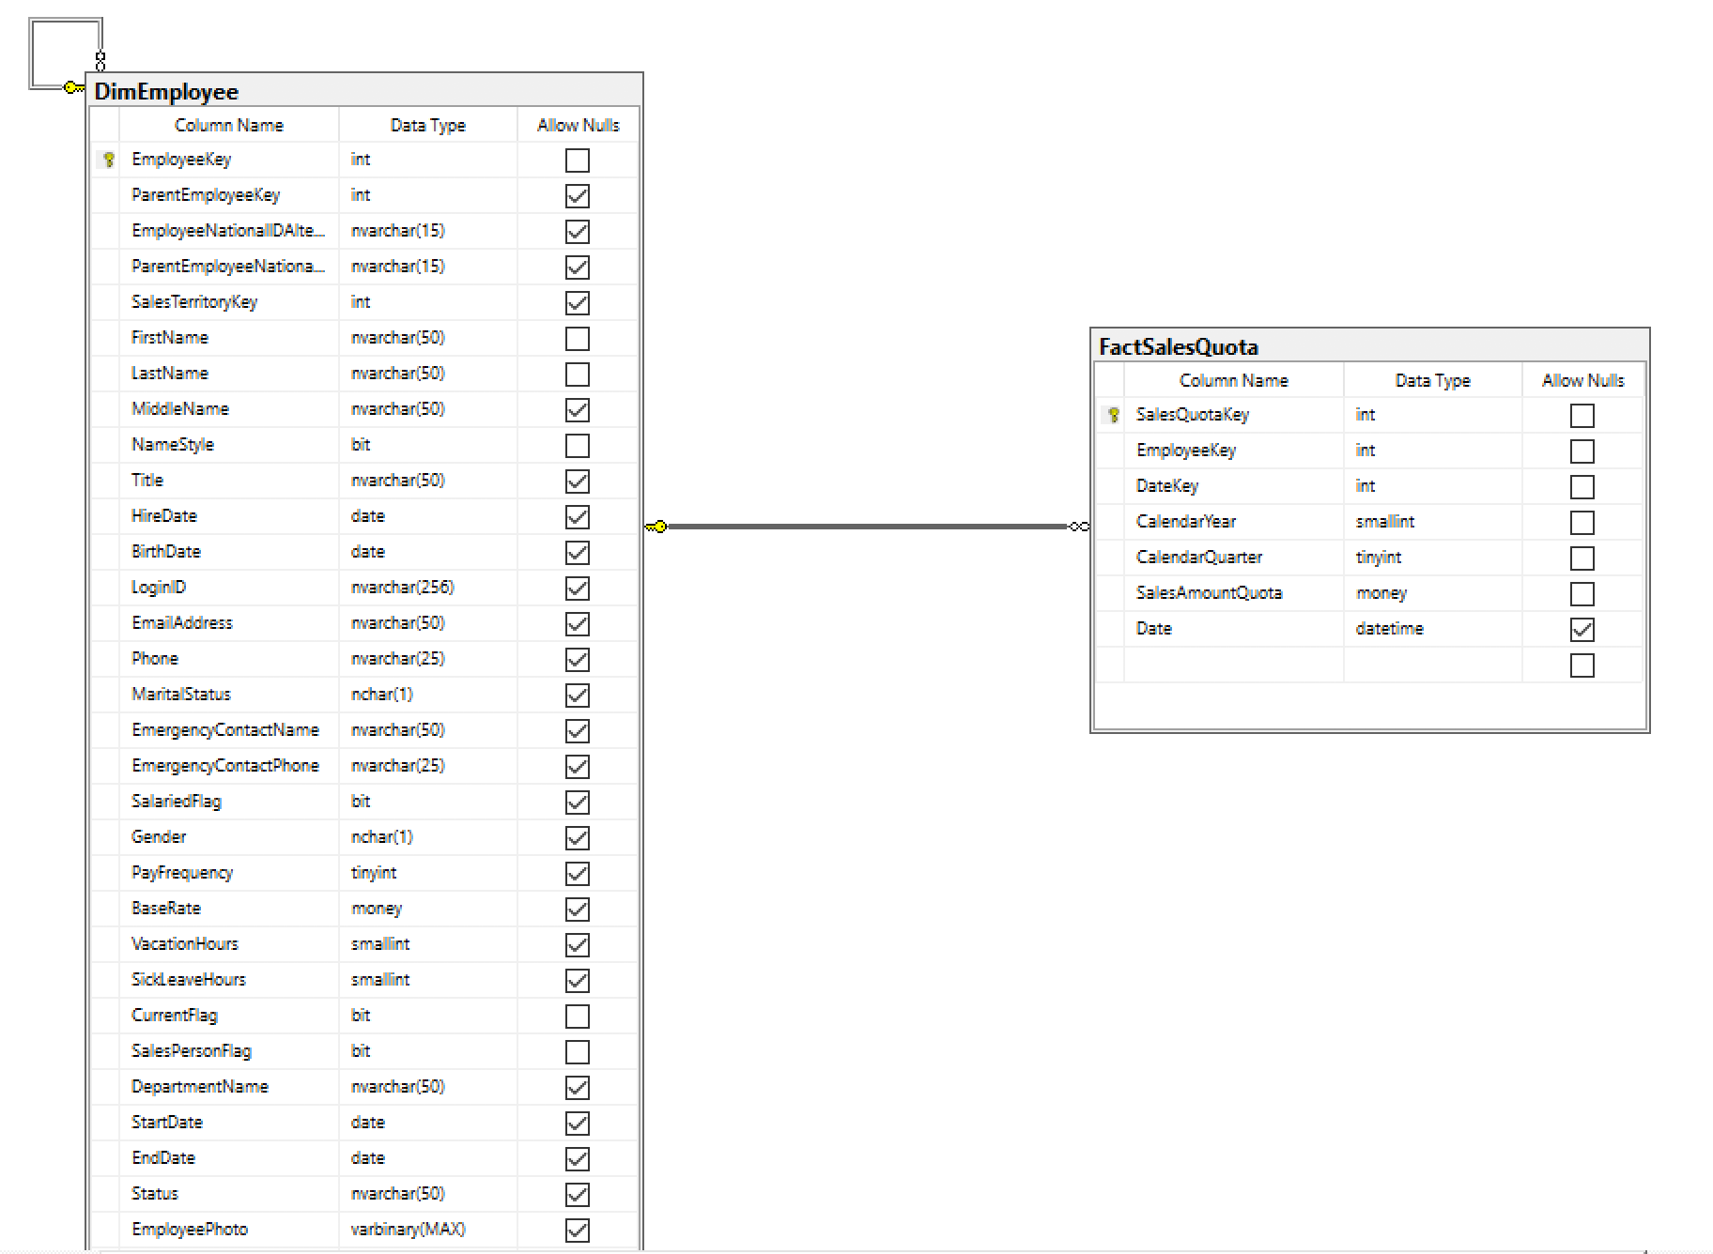

## 

## CODE:

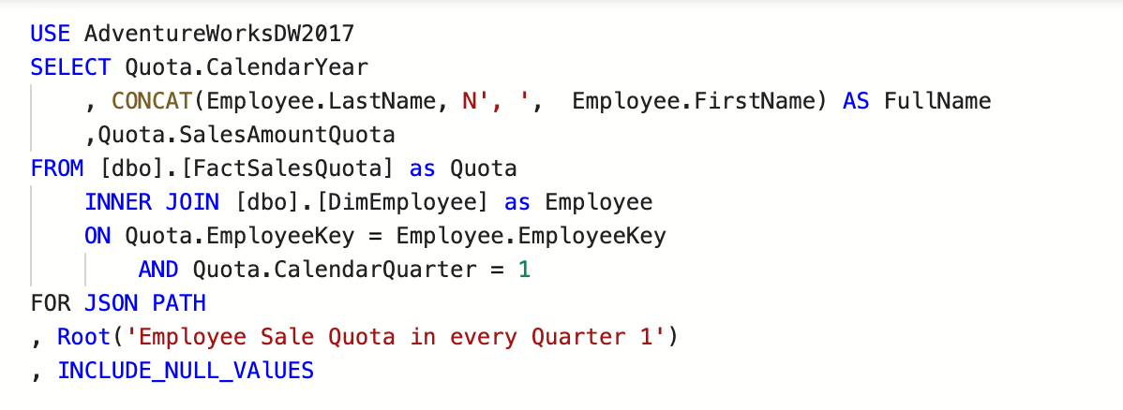

## JSON Path:

## 

## Result Table:

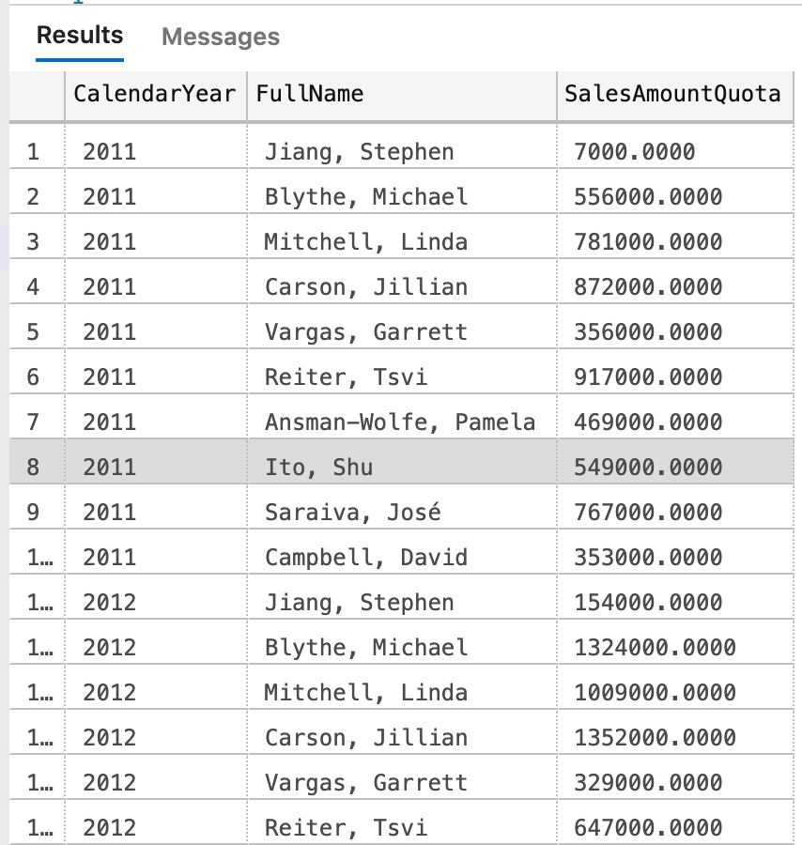

(3rows affected)

## Required Table:

|  |  |
| --- | --- |
| Table Name | Column Name |
| dbo.FactSalesQuota | CalendarQuarter  CalenderYear |
| Derived Column | FullName |

# Medium Problem 1

**Proposition:** returns all orders place in 2014 and count out the sum of Total Price and how many orders place

**Query Required:** Northwind2020

**Table Required: :** Sales.Order, Sales.OrderDetail

**Problem Description:**

Find all orders place in 2014 and count out the sum as Total Price and see how many orders place. In this problem you need to use group by in order to count how many orders place in each order id and calculate the sum of the product of the unit price and quantity to get the sum of total price. List the Price which is sum of total price, number of orders, customer id and ordered. Perform inner join between the two tables.

## Key View:



## Standard View:

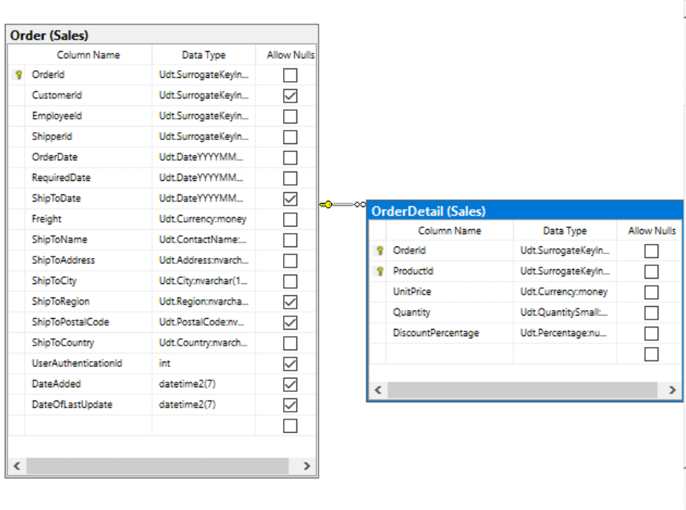

## Code:

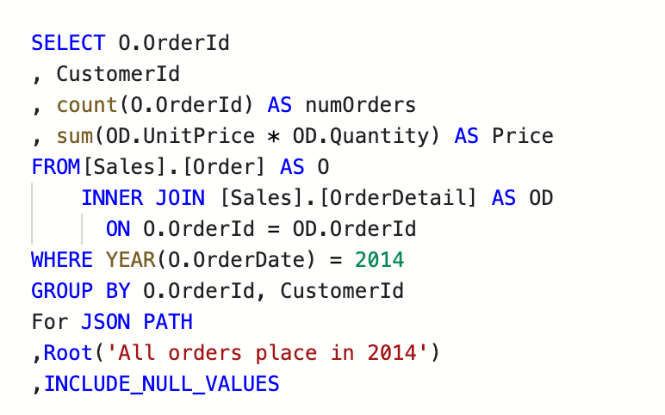

## JSON Path:

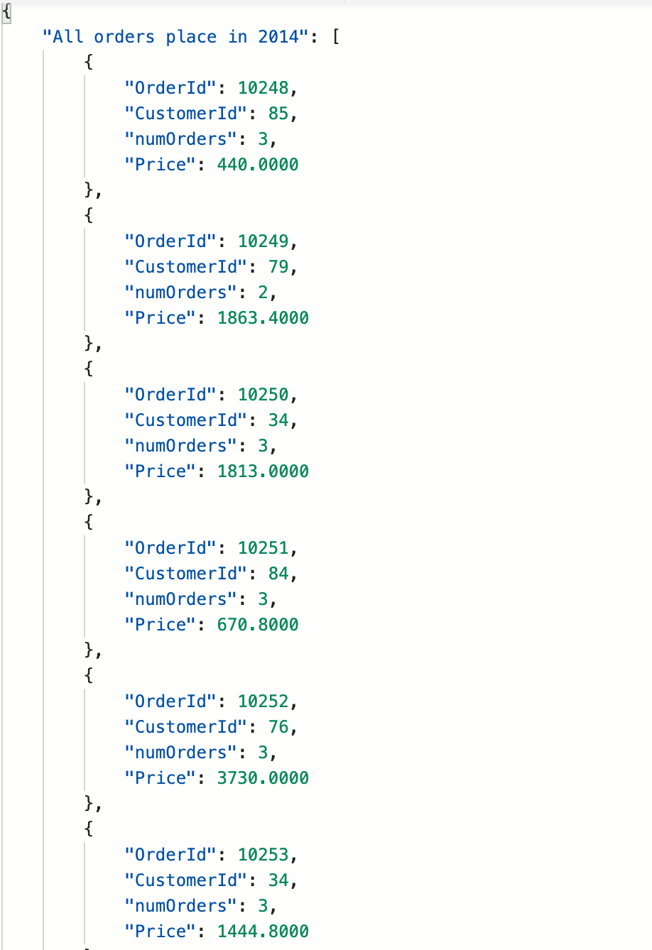

## Result Table:

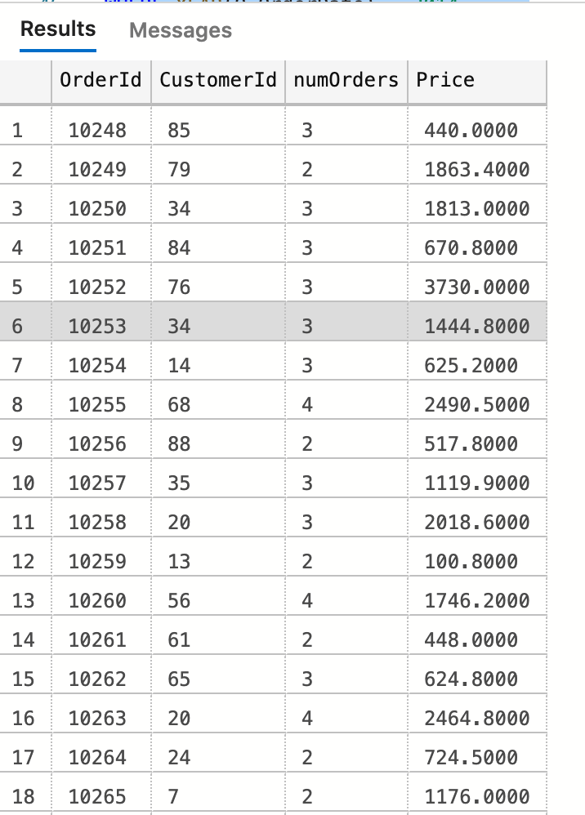

(152 rows affected)

## Required Table:

|  |  |
| --- | --- |
| Table Name | Column Name |
| Sales.Order | **Orderid**  **Customerid** |
| Sales.OrderDetail | **N/A** |
| Derived Column | **Price**  **numOrders** |

# Medium Problem 2

**Proposition: return:** all the product that are Discontinued

**Query Required:** Northwind2020

**Table Required:** Production.Product and Production.Supplier

**Problem Description:**

Create a query that finds all orders that are discontinued. List all supplier country, and number of suppliers in country. Perform an join between the two tables. Use Northwind 2020 and tables Production.Product and Production.Supplier.

## Key View:



## Standard View:



## Code:

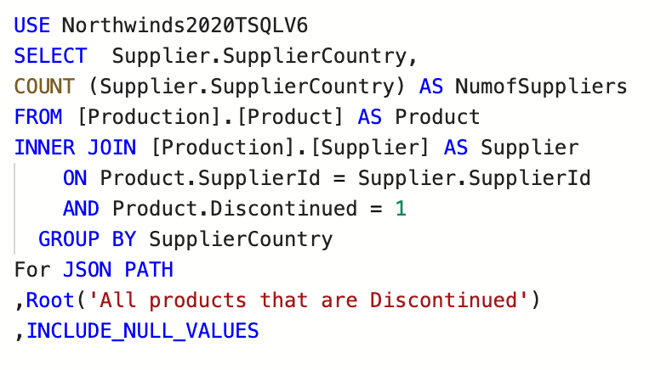

## JSON Path:

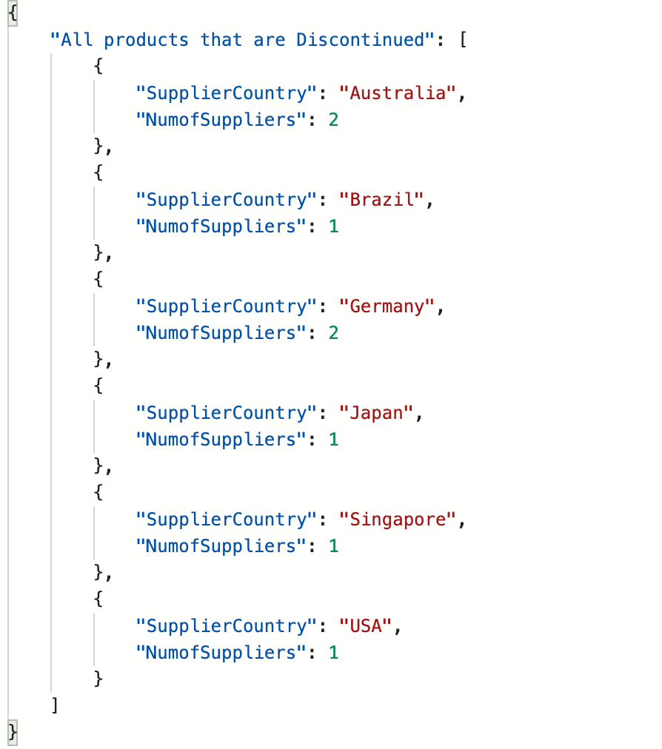

## Result Table:

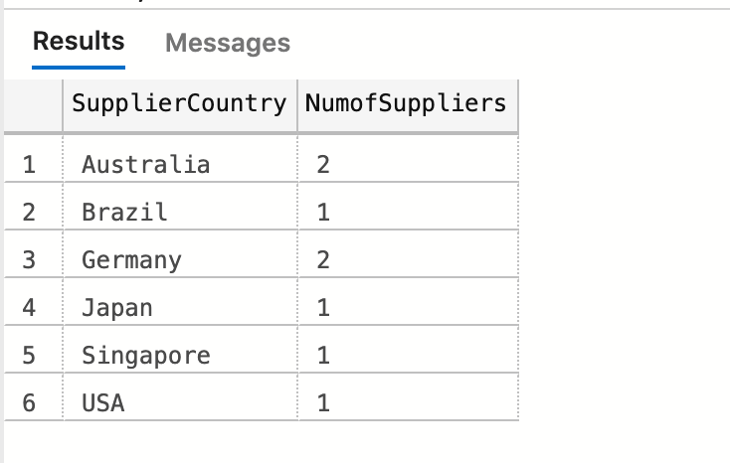

(6 rows affected)

## Table Required:

|  |  |
| --- | --- |
| Table Name | Column Name |
| Production.Supplier | **SupplierCountry** |
| Production.Product | **N/A** |
| Derived Column | **NumofSuppliers** |

# Medium Problem 3

**Proposition:** return top 10 order that has the highest total unit price and order id is at most 10400

**Query Required:** Northwind2020

**Table Required:** Sales.Order, and Sales.OrderDetail

**Problem Description:**

Find top 10 order that has the highest total unit price and order id is at most 10400. List the orderdate, number of orders and totalunitprice by summing up all unit price. Inner join the table Sales.Order and Sales.OrderDetail and use query Nortwind2020.

## Key View:



## Standard View:

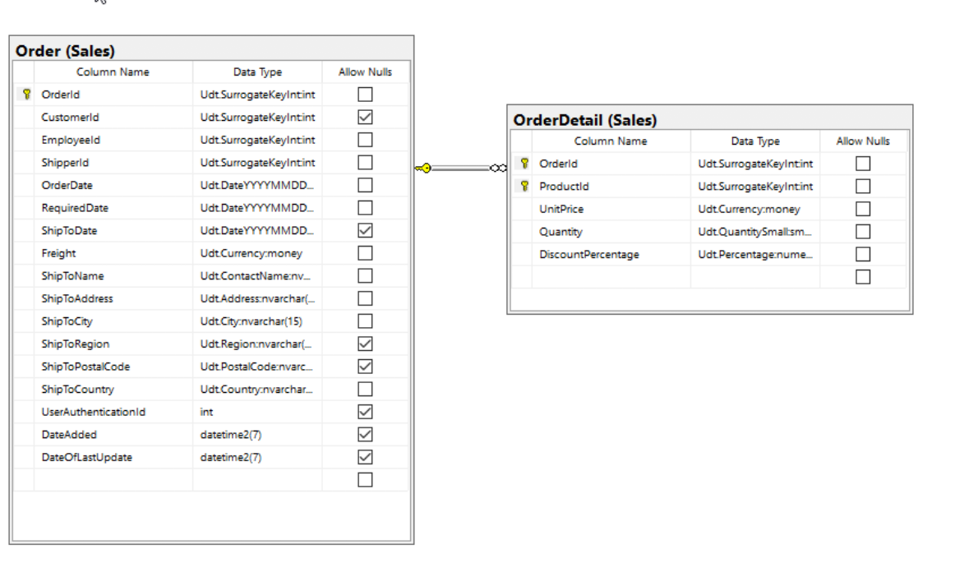

## Code:

## JSON Path:

## 

\

## Result Table:

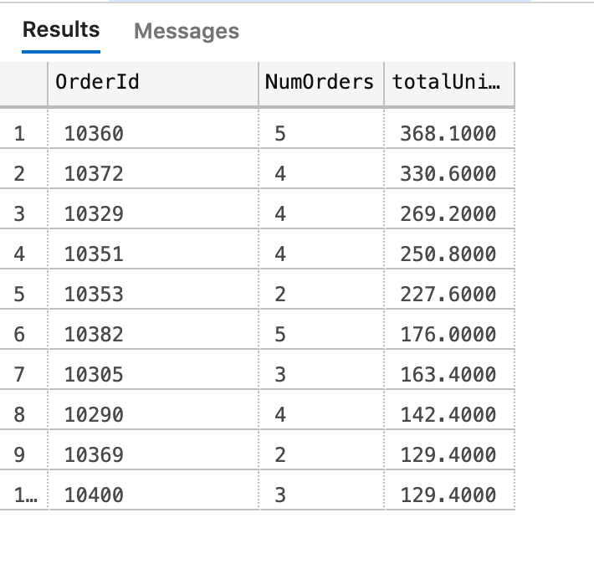

(10 rows affected)

## Table Required:

|  |  |
| --- | --- |
| Table Name | Column Name |
| Sales.Order | **Orderid** |
| Sales.OrderDetail | **N/A** |
| Derived Column | **TotalUnitPrice**  **NumOrders** |

# Medium Problem 4

**Proposition:** returns the number of quota and sum of quota of each employee

**Query Required:** AdventureWorks2017

**Table Required:** Person.Person and Sales.SalesPersonQuotaHistory

**Problem Description:**

Create a query that finds all the number of quota and sum quota of each employee return the employee id, firstname,lastname , number quota and total quota.List all employee id, firstname, lastname, numQuata as number of quotas and total quota which is the sum of the quota. Perform inner join on the Person.Person and Sales.SalesPersonQuotaHistory and use AdventureWorks2020

## Key View:

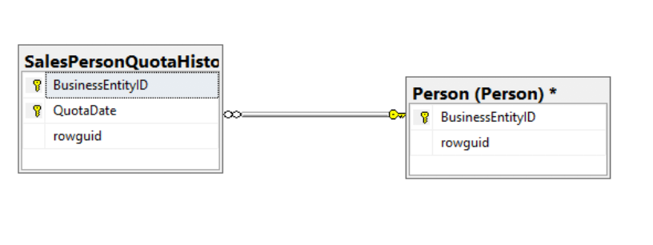

## Standard View:

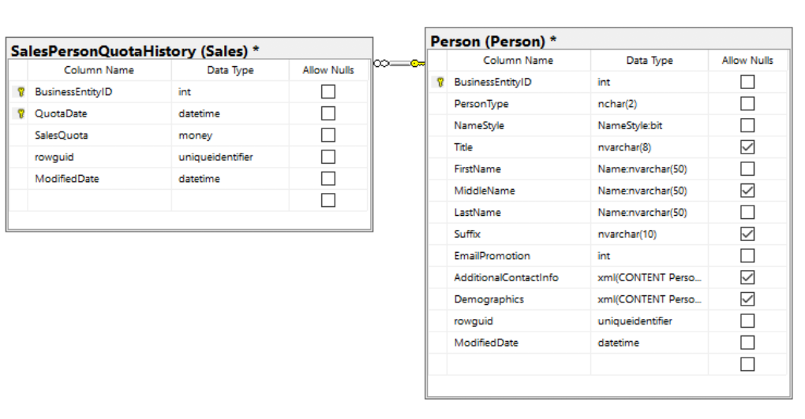

## Code:

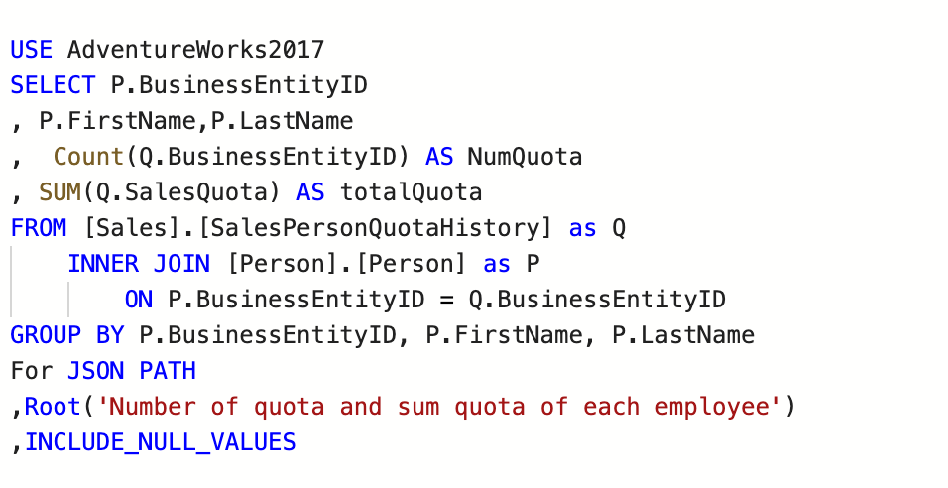

## JSON Path:

## Result Table:

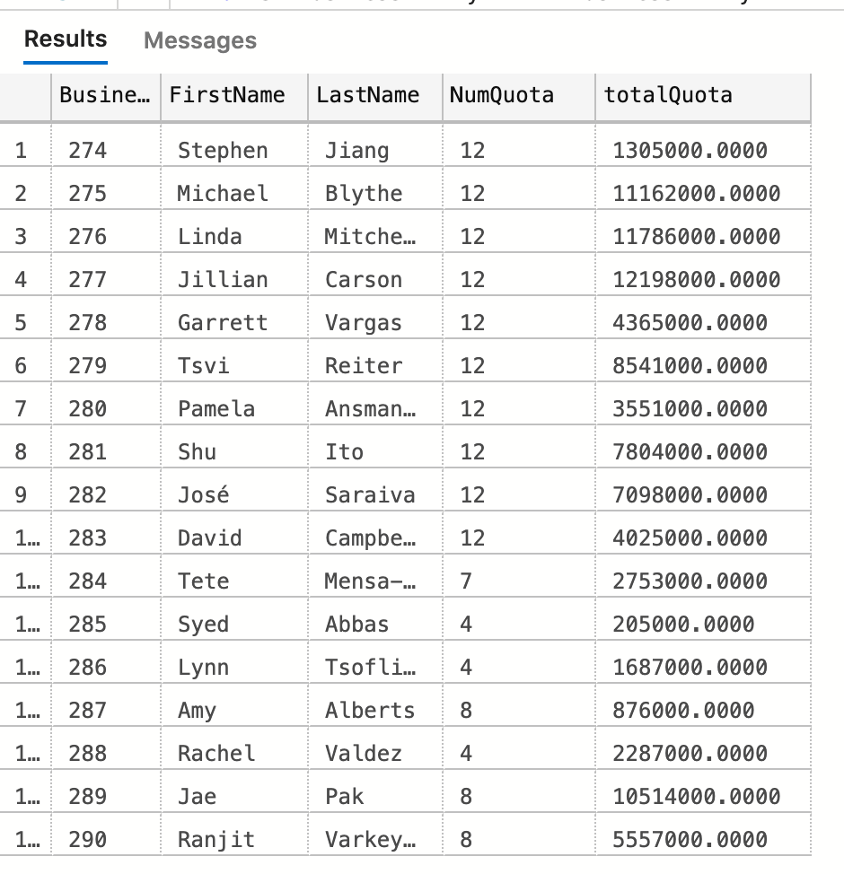

(17 rows affected)

## Required Table:

|  |  |
| --- | --- |
| Table Name | Column Name |
| Sales.SalesPersonQuotaHistory | **BuisnessEntityID**  **Firstname**  **Lastname** |
| Person.Person | **N/A** |
| Derived Column | NumQuota  TotalQuota |

# Medium Problem 5

**Proposition:** return all employees who's bonus are lower than $1000

**Query Required:** AdventureWorks2020

**Table Required:** Sales.SalesPerson and Person.Person

**Problem Description:**

Find all employees with bonus lower than 1,000. List all employee’s businessEntityid , First name, last name and their bonus. Perform inner join between Sales.SalesPerson and Person.Person and use AdventureWorks2020

## Key View:

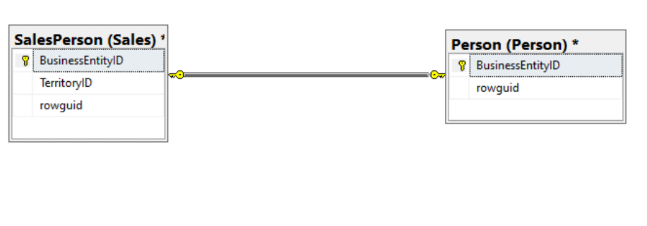

## Standard View:

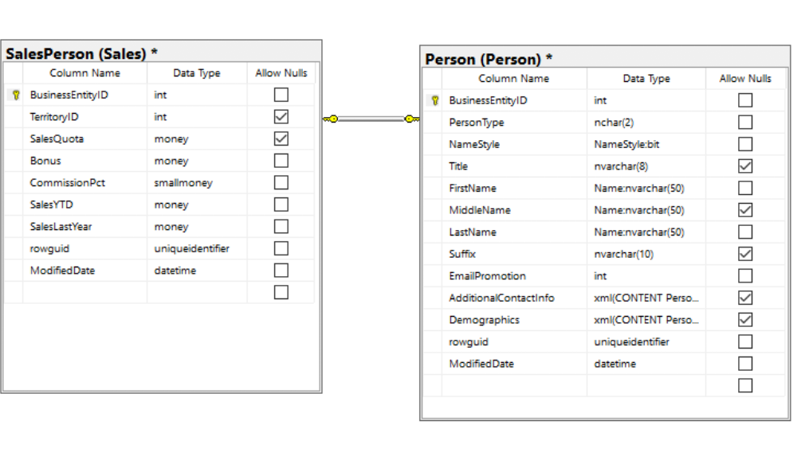

## Code:

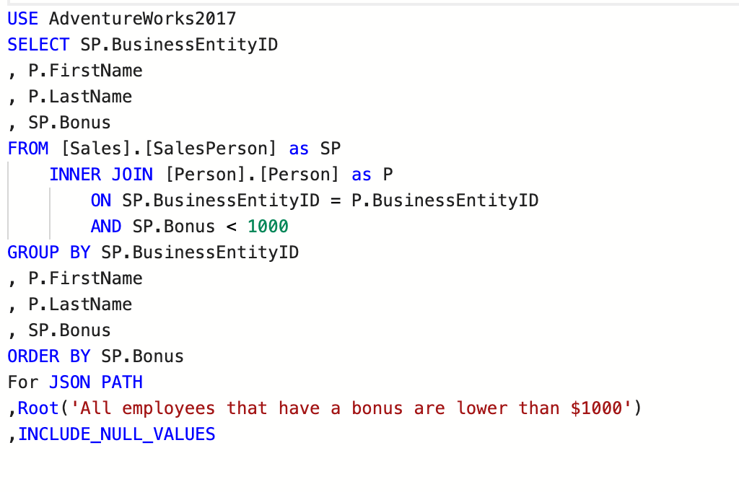

## JSON Path:

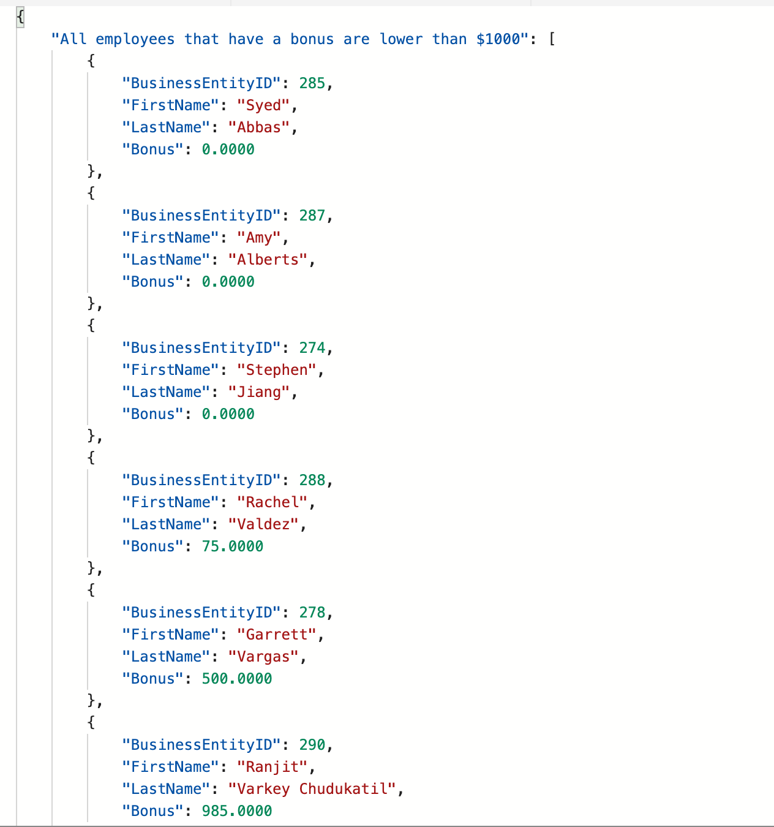

## Required Table:

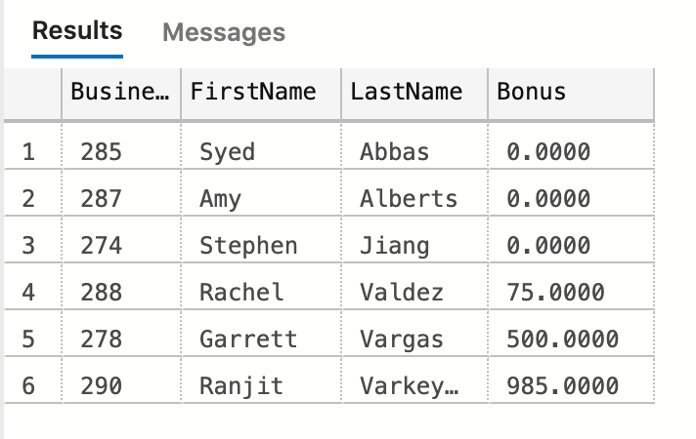

(6 rows affected)

## Table Required:

|  |  |
| --- | --- |
| Table Name | Column Name |
| Sales.SalesPerson | **BuisnessEntityID**  **Bonus** |
| Person.Person | **FirstName**  **LastName** |

# Medium Problem 6

**Proposition:** Return the total cost and number productline where orderdate from January 2012 to May 2012

**Query Required:** AdventureWorksDW2017

**Table Required:** dbo.FactResellerSales, dbo.DimReseller

**Problem Description:**

Create a query that find the total cost and number productline where orderdate are in within January 2012 to May 2012. List all orderdate, product line, numproduct as number of productline, and sum of totalcost use AdventureWorksDW2017. Perform inner join of the two queries dbo.FactResellerSales, dbo.DimReseller.

## 

## Key View:

## Standard View:

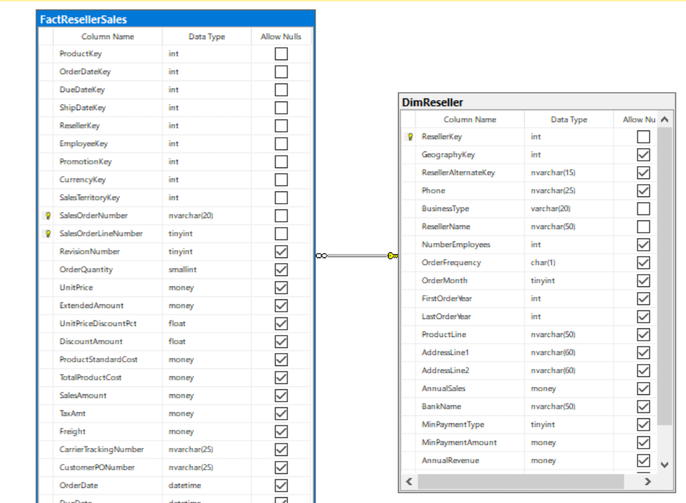

## Code:

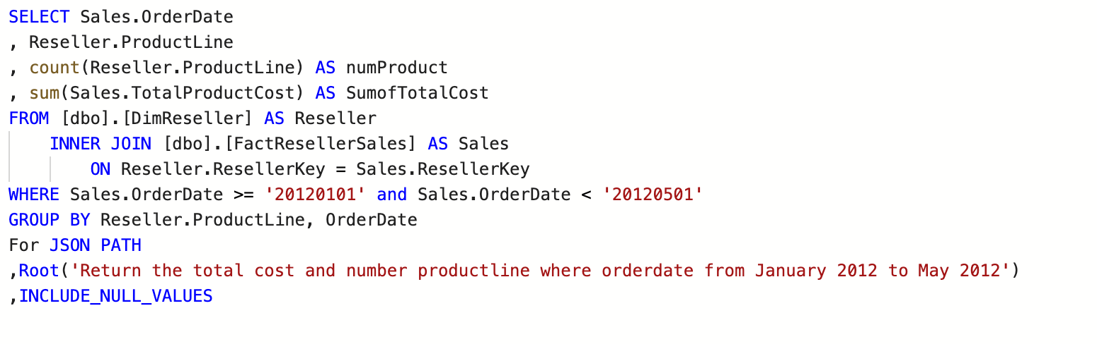

## JSON Path:

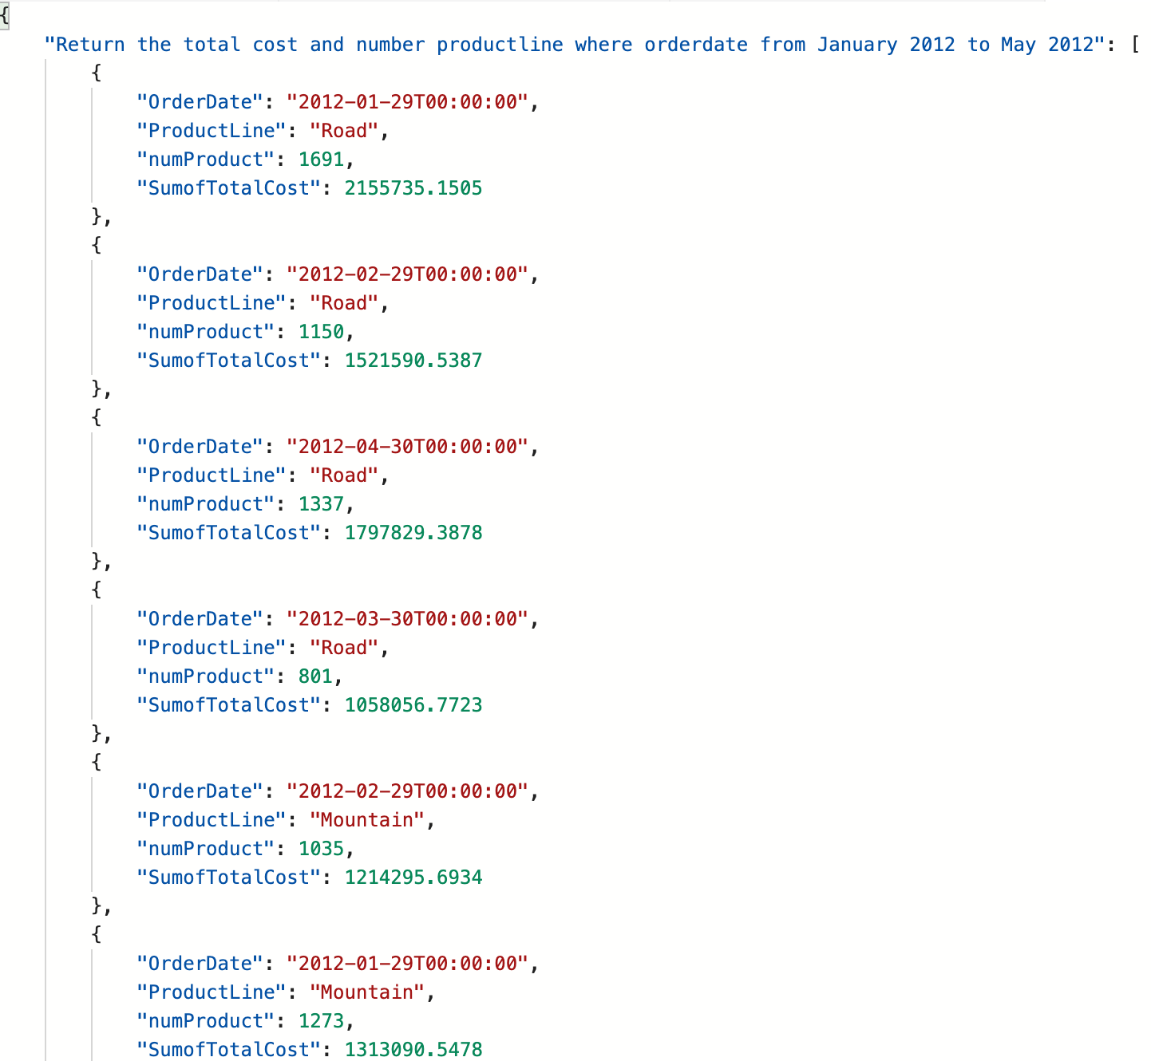

## Result Table:

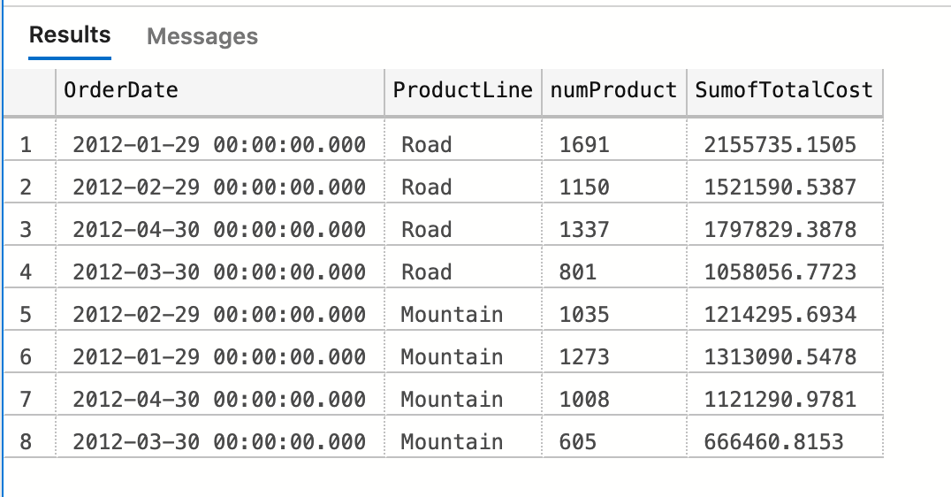

(8 rows affected)

## Required Table:

|  |  |
| --- | --- |
| Table Name | Column Name |
| dbo.FactResellerSales | **OrderDate** |
| dbo.DimReseller | **ProductLine** |
| Derived Column | **numProduct**  **SumTotalCost** |

# 

# Medium Problem 7

**Proposition:** return all customer fullname and location in France

**Query Required:** AdventureWorksDW2017

**Table Required:** dbo.DimGeography and dbo.DimCustomer

**Problem Description:**

Create a query that return all customer from France. List the Fullname which is the first name and last name and Location which has city and region. Perform inner join of dbo.DimGeography and dbo.DimCustomer. Use AdventureWorksDW2017 as query.

## Key View:

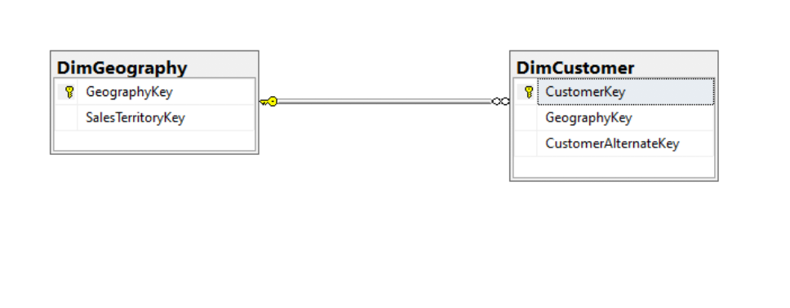

## Standard View:

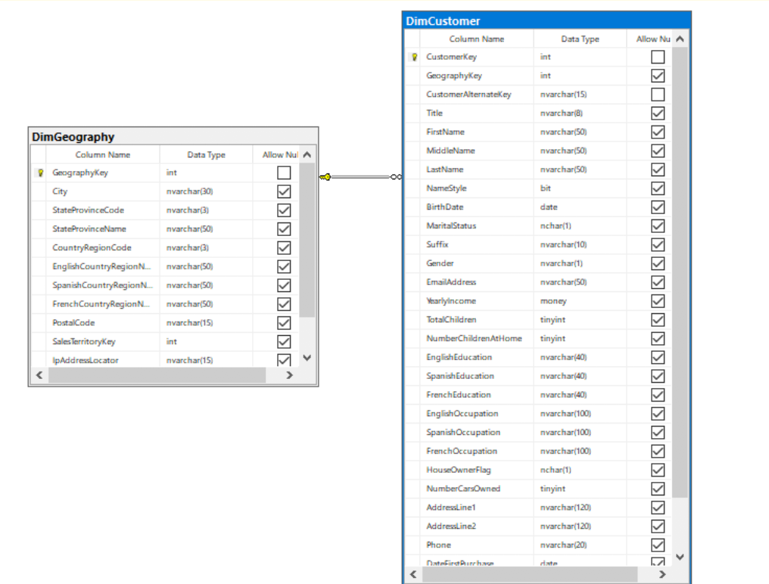

Code: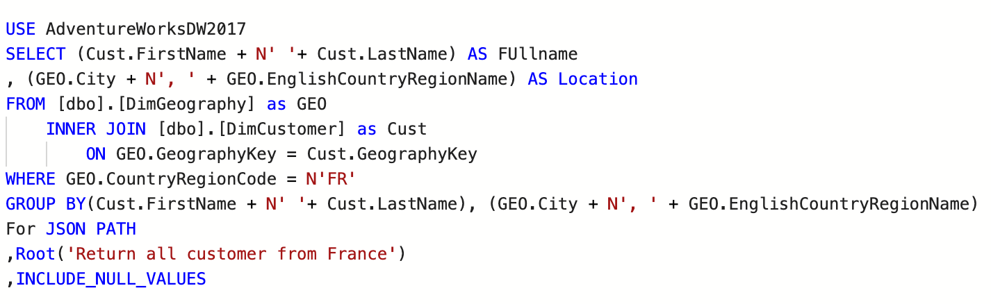

## JSON Path:

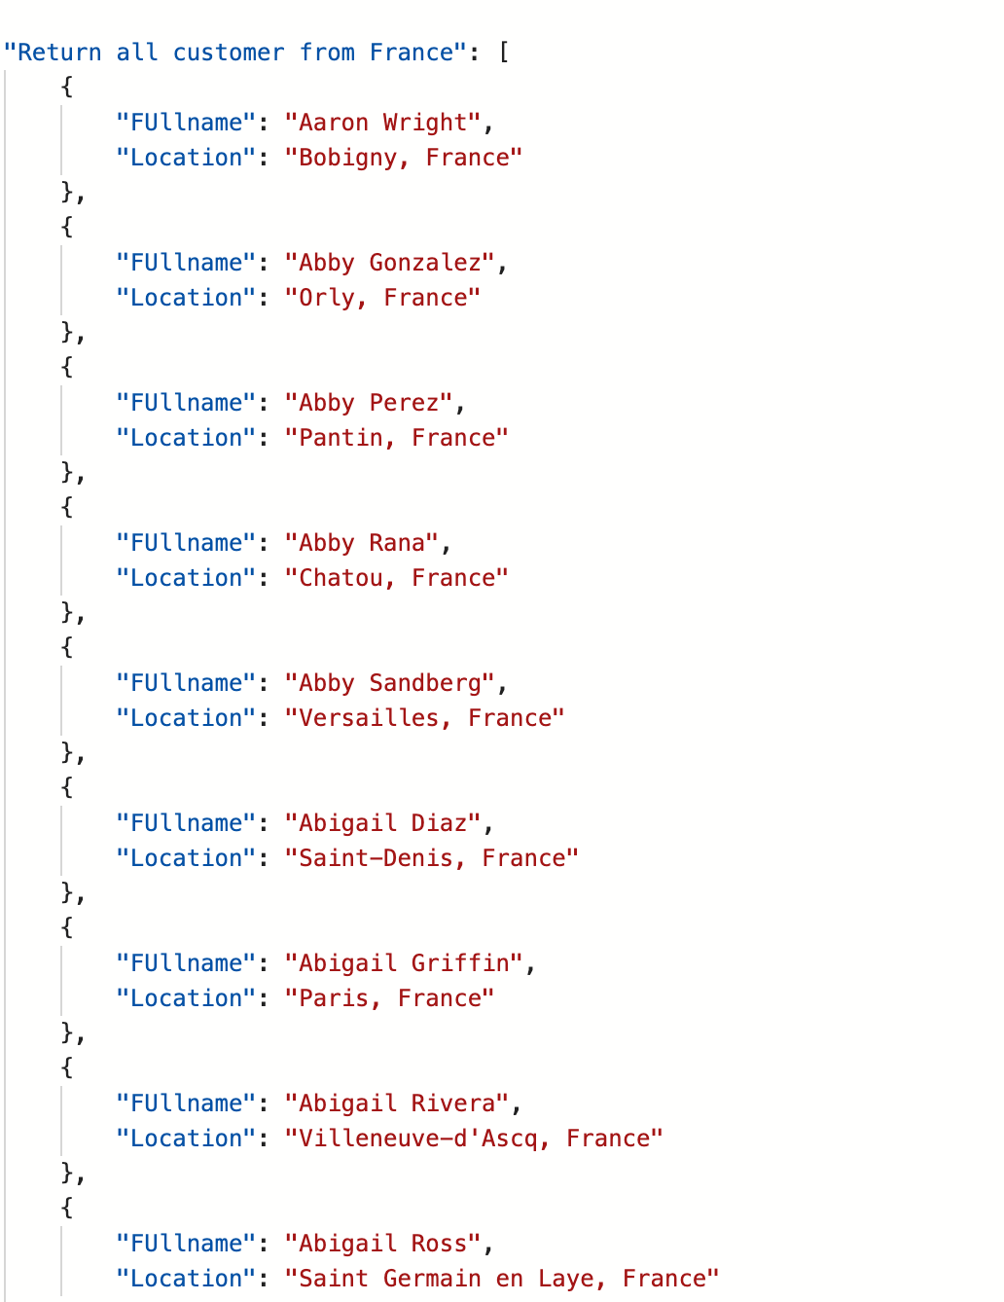

## 

## Result Table:

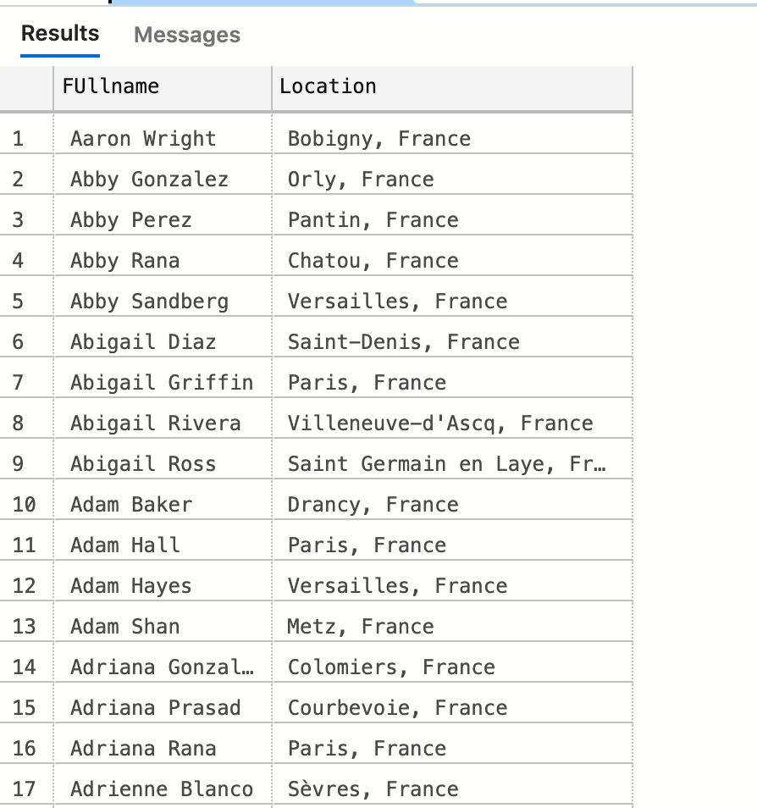

(1810 rows affected)

## Table Required:

|  |  |
| --- | --- |
| Table Name | Column Name |
| Dbo.DimGeography | N/A |
| dbo.DimCustomer | N/A |
| Derived Column | Fullname  Location |

# Medium Problem 8

**Proposition:** return all product that has product category key at most 2

**Query Required:** AdventureWorksDW2017

**Table Required:** dbo.DimProductCategory and dbo.DimProductSubCategory

**Description:**

Create a query that finds all products with the category key of at most 2 using AdventureWorksDW2017 . Return the products Category Key, Category Name and Subcategory Name. join the two tables dbo.DimProductCategory and dbo.DimProductSubCategory.

## Key View:

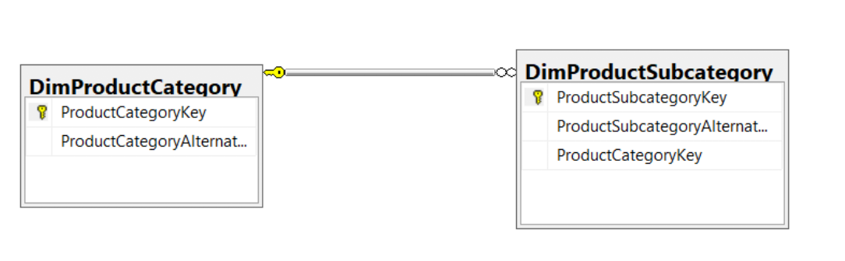

## Standard View:

## Code:

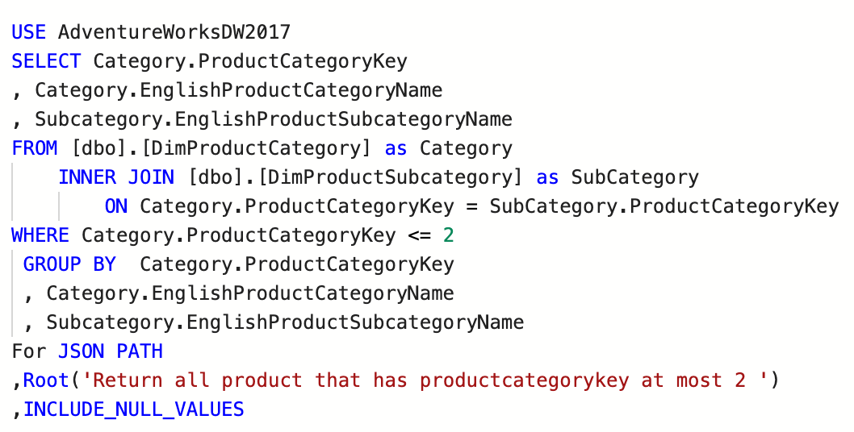

## JSON Path:

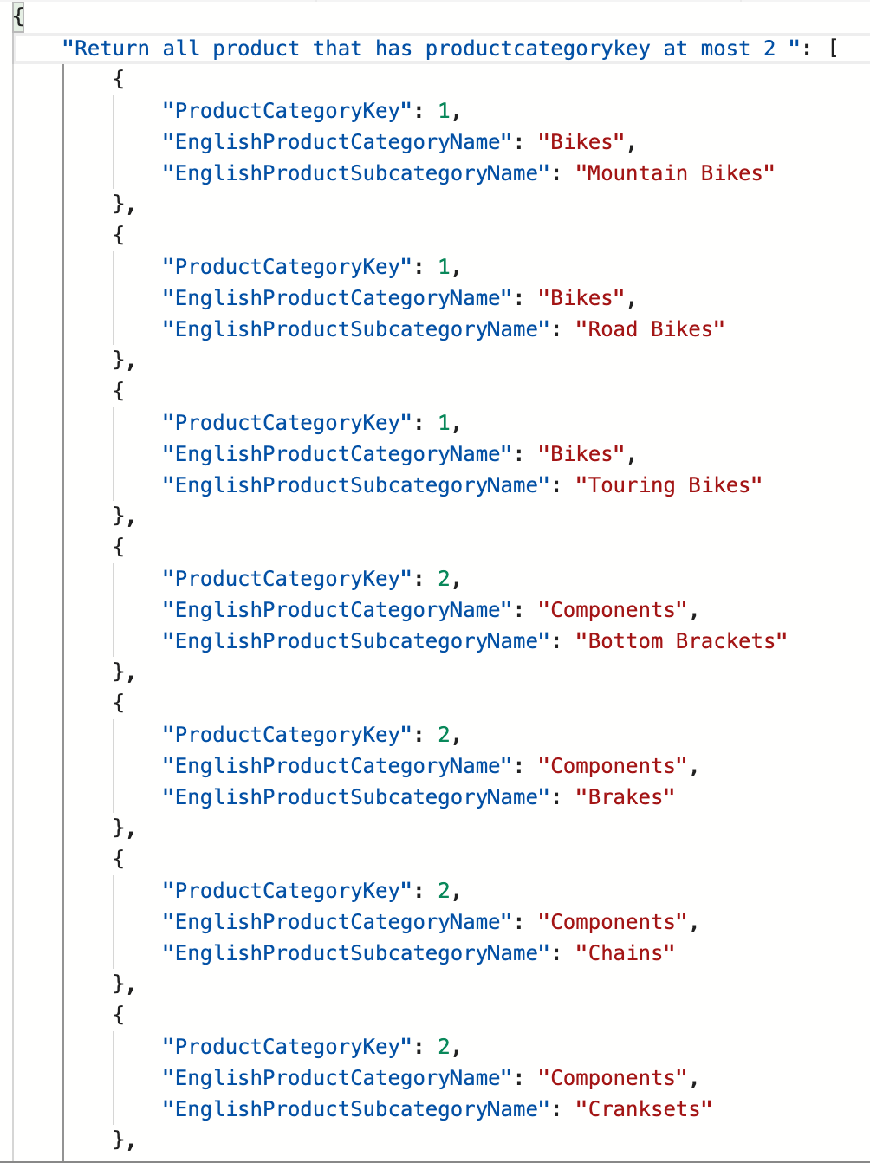

## Result Table:

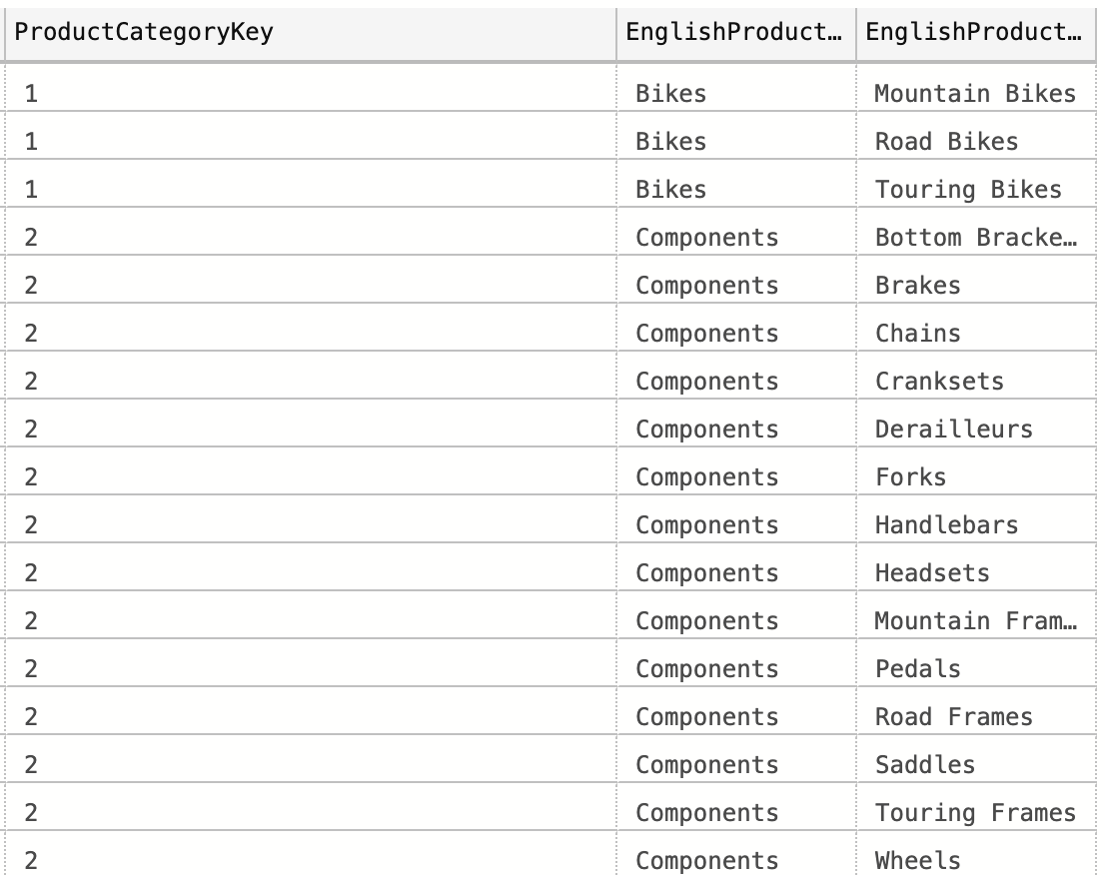

(17 rows affected)

## Required Table:

|  |  |
| --- | --- |
| Table Name | Column Name |
| dbo.DimProductCategory | **ProductCategoryKey**  **EnglishProductCategoryName** |
| dbo.DimProductSubCategory | **EnglishProductSubCategoryName** |

# Complex Problem 1

**Proposition:** return all orders done in 2015 and done by US employee

**Query Required:** Northwind2020

**Table Required:** Sales.Order. Sales.OrderDetail, HumanResources.Employee

**Problem Description:**

Create a query that return all orders done in 2015 and done by US employee and create a scalar function called PriceofSale. The scalar Function Price of Sale should take in 3 parameters and they are unit price, quantity and discountpercentage. In the scalar function the result you are returning is Sales Price of the order. To calculate the sales price you have to take regular price minus the discount price. In the query, you are task to find the all occurrence of each order date done 2015 and done by US customers. Then you calculate the sum of all SalesPrice as SalesPrice. List all orders, number of orders, and salesPrice which is the sum all salesprice. Perform 2 inner joins between Sales.Order. Sales.OrderDetail, and HumanResources.Employee. and use Northwind as your query

## Key View:

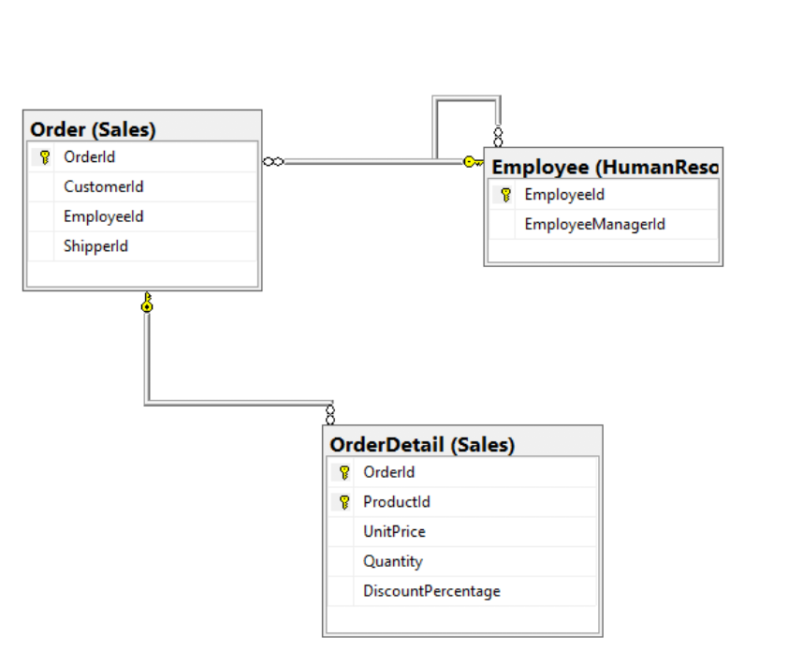

## Standard View:

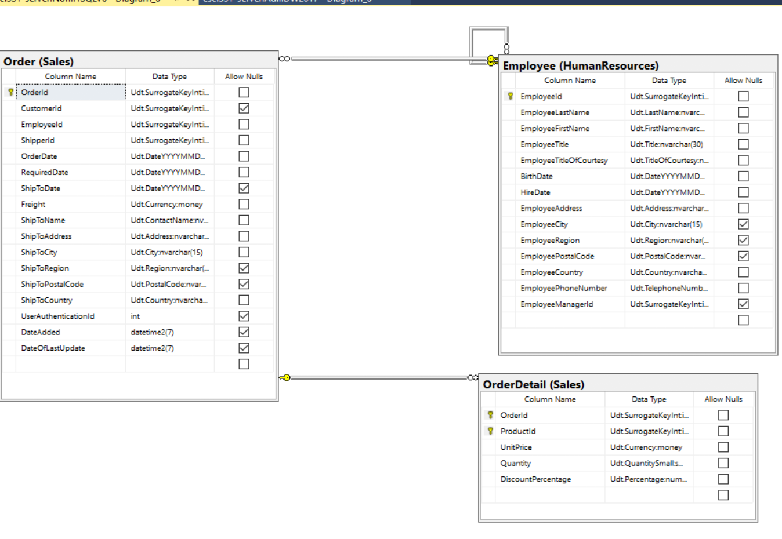

## 

## Code:

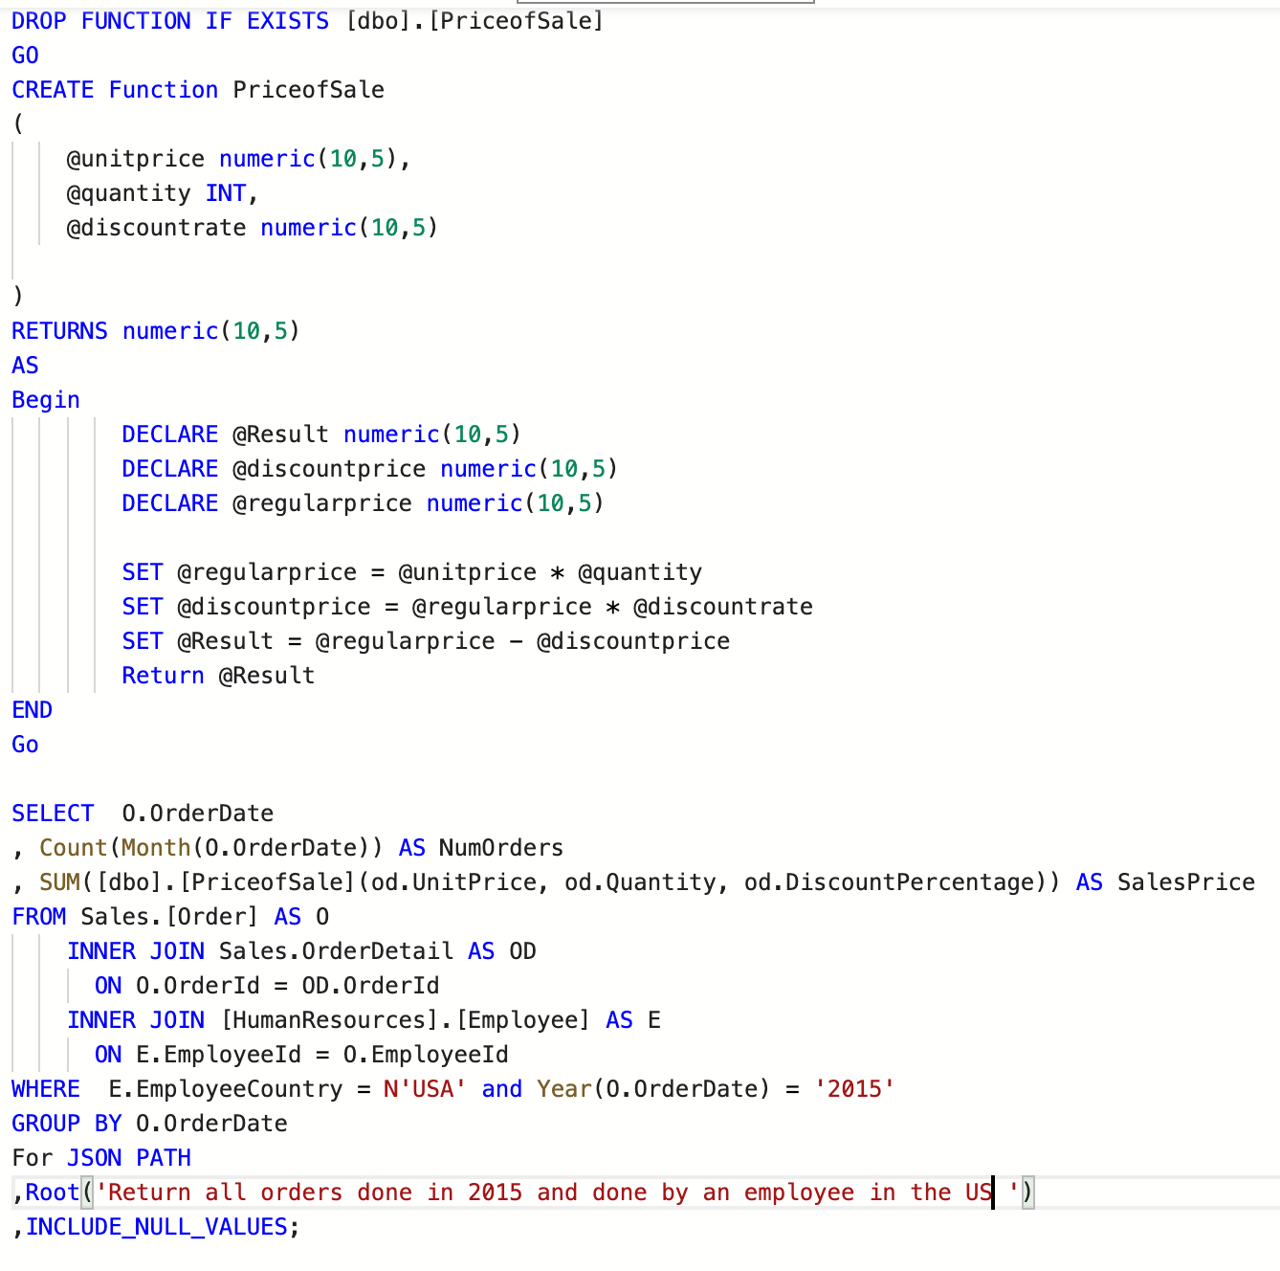

## 

## JSON Path:

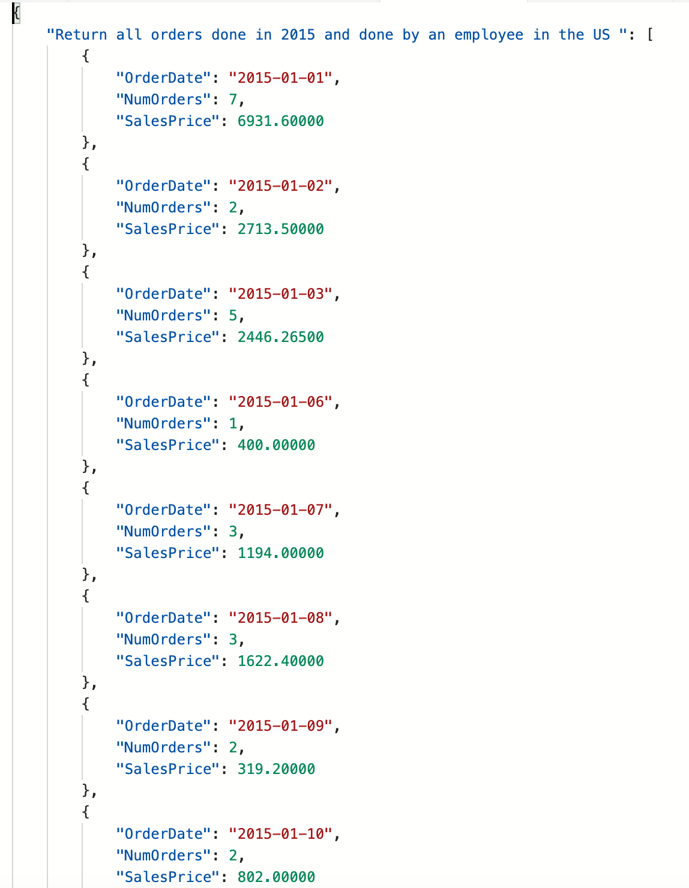

## Result Table:

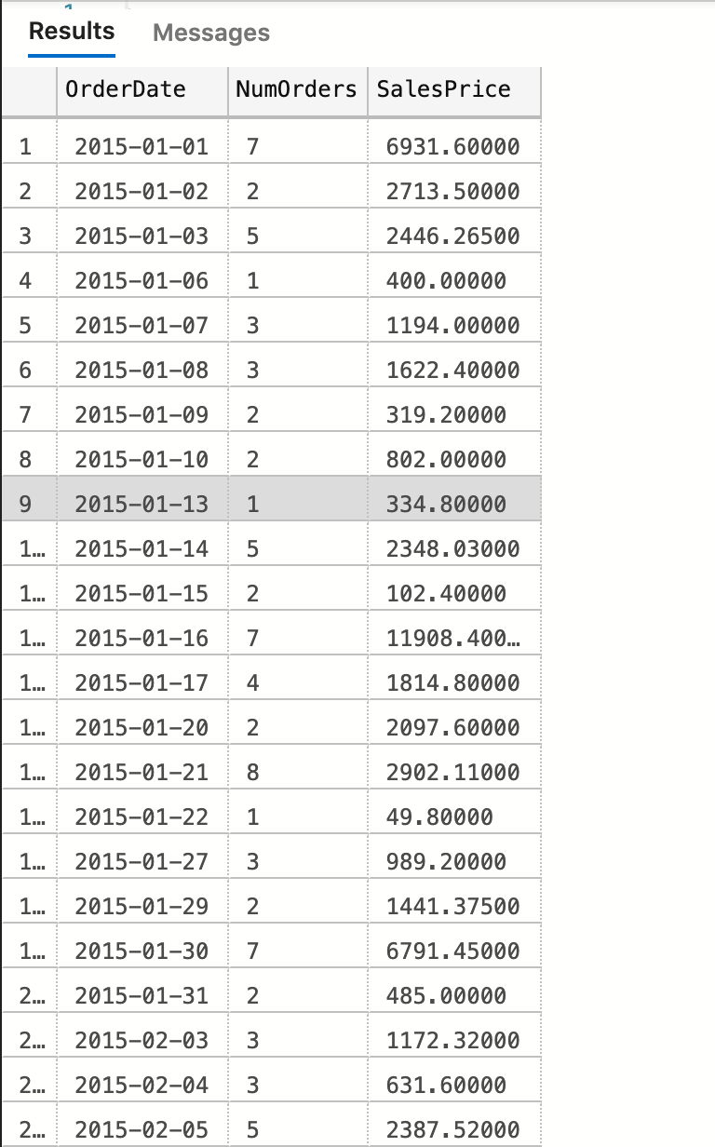

(224 rows affected)

|  |  |
| --- | --- |
| Table Name | Column Name |
| Sales.Order | **OrderDate** |
| Sales.OrderDetail | **N/A** |
| HumaResource.Employee | **N/A** |
| Derived Column | **NumOrders**  **SalesPrice** |

# Complex Problem 2

**Proposition:** returns all orders between January 2016 to March 2016 return the row 15 to 25 of the table

**Query Required:** Northwind2020

**Table Required:** Sales.Order, Sales.OrderDetail, Production.Product

**Problem Description:**

Create a scalar function that prints description. Description returns days it took before order is shipped

It takes 2 parameters which is orderdate and shippeddate. Find the difference of the two to get the time before order is shipped.

Create A query that returns all orders between January 2016 to March 2016. List the Orderdate, unit price, productname and Description which calls on the scalar function. Perform 2 query join on Sales.Order, Sales.OrderDetail, Production.Product and use Northwind2020.

## Key View:

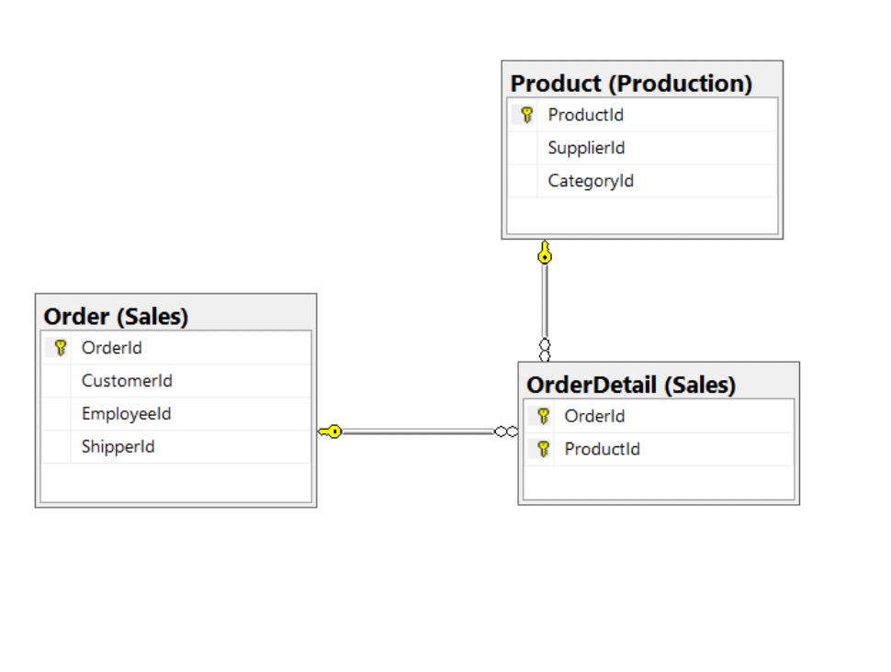

## Standard View:

## 

## 

## Code:

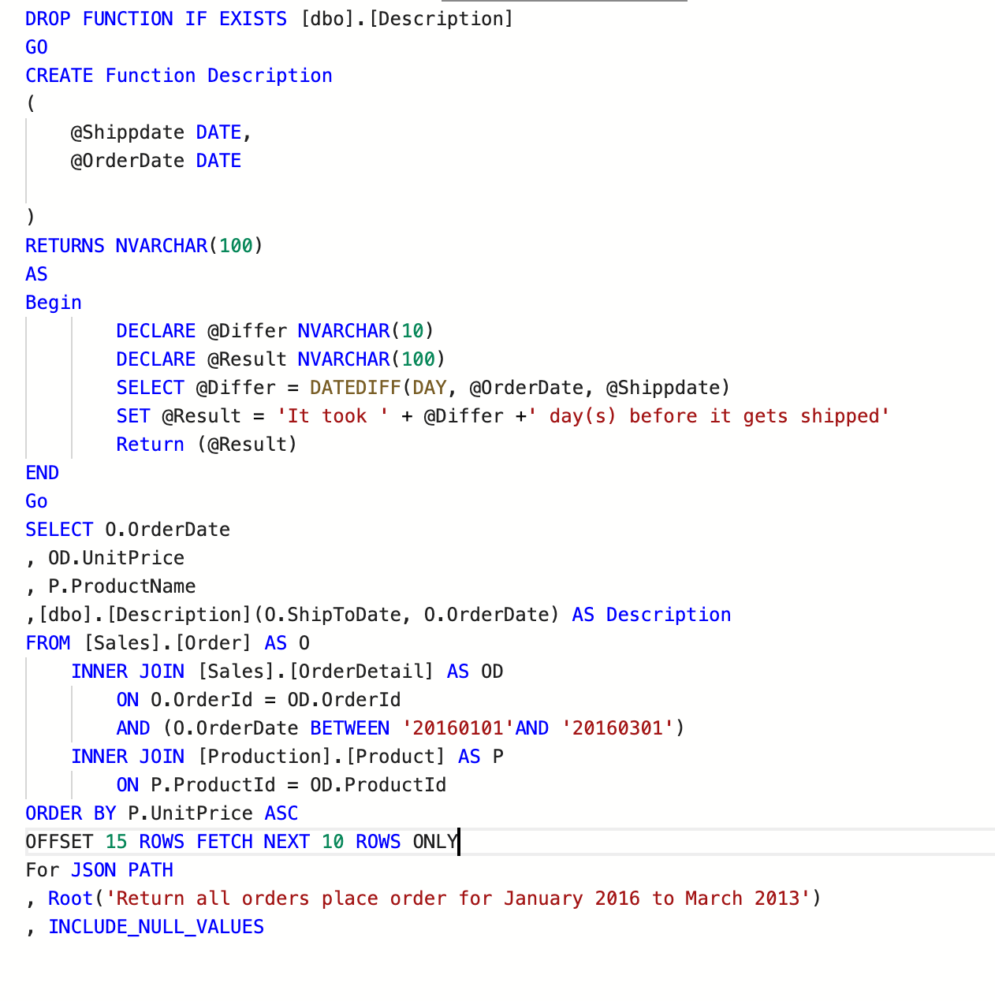

## JSON Path:

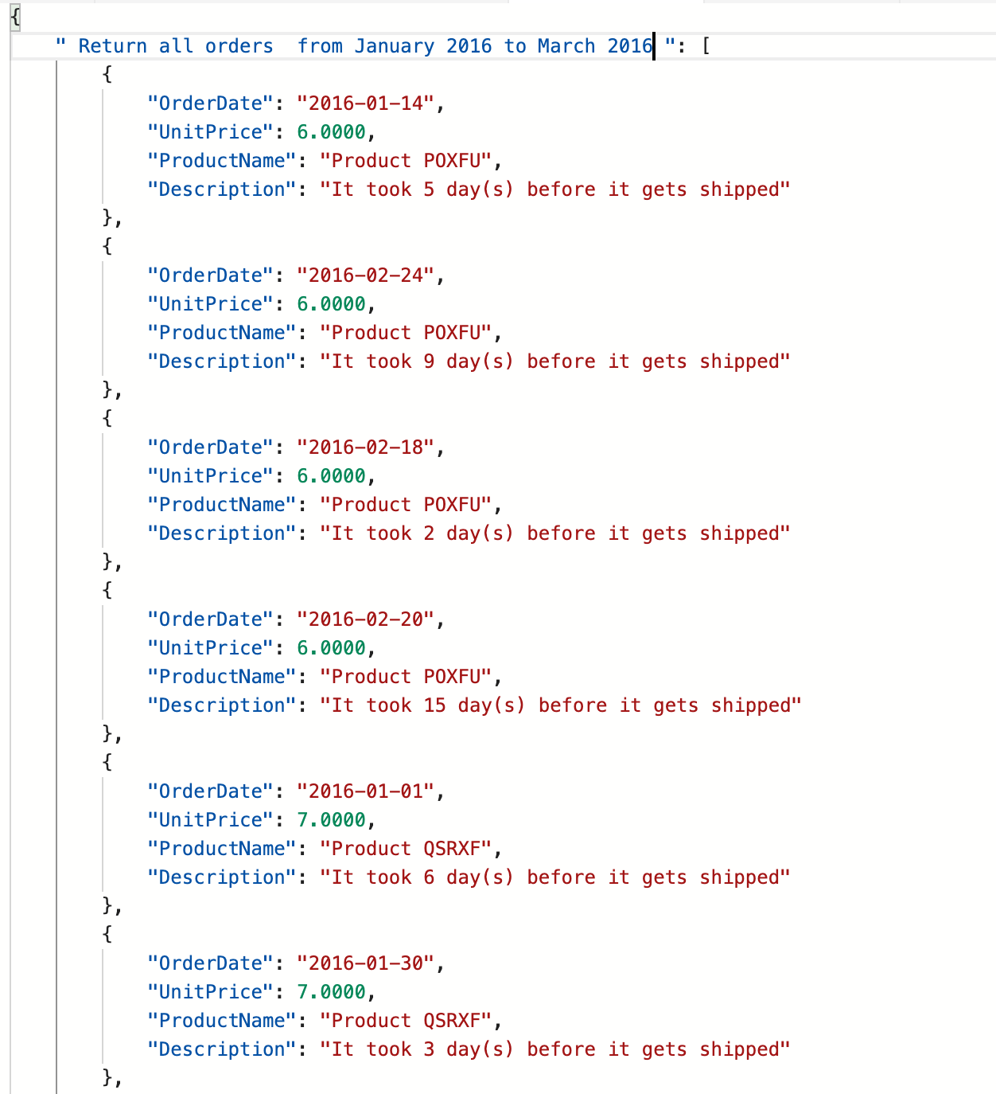

## Result Table:

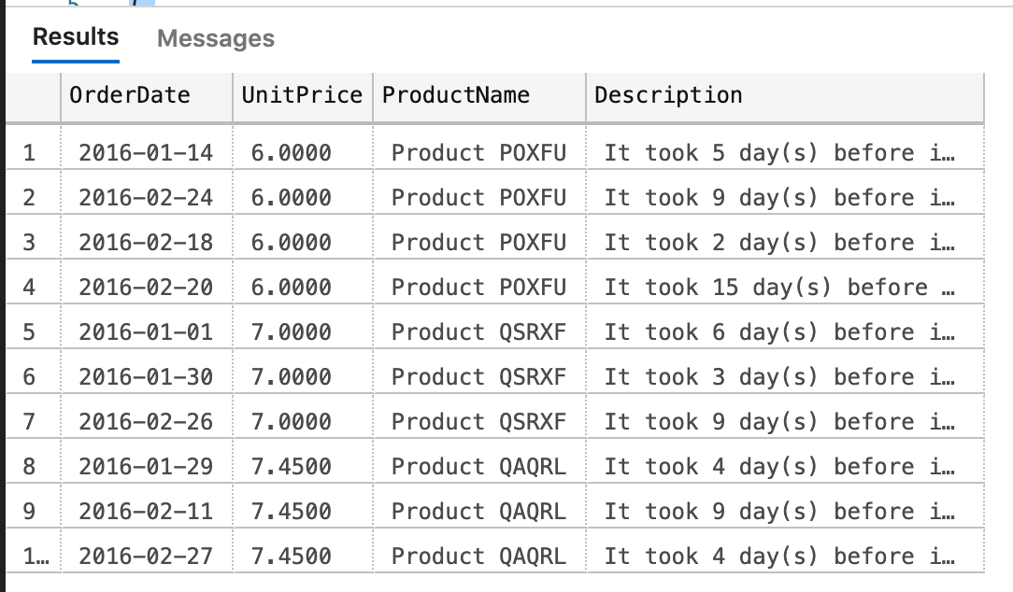

(10 rows affected)

## Required Table:

|  |  |
| --- | --- |
| Table Name | Column Name |
| Sales.Order | **OrderDate** |
| Sales.OrderDetail | **Unit Price** |
| Production.Product | **ProductName** |
| Derived Column | **Description** |

# Complex Problem 3

**Proposition:** returns all orders place in 2013 and later that are not use customer

**Query Required:** Adventure Works 2017

**Table Required:** Sales.OrderHeader, Sales Customer, Sales.Territoy

**Problem Description:**

Create a scalar function that prints description. Description returns days it took before order is shipped

It takes 2 parameters which is orderdate and shippeddate. Find the difference of the two to get the time before order is shipped.

Create a query that returns all orders place in 2013 and later that are not use customer. List all order dates. Customer Id, region code and Description which calls on the scalar function that calculates the days before it gets shipped. Perform 2 query join on Sales.OrderHeader, Sales Customer, and Sales.Territoy and use AdventureWorks2017

## Key View:

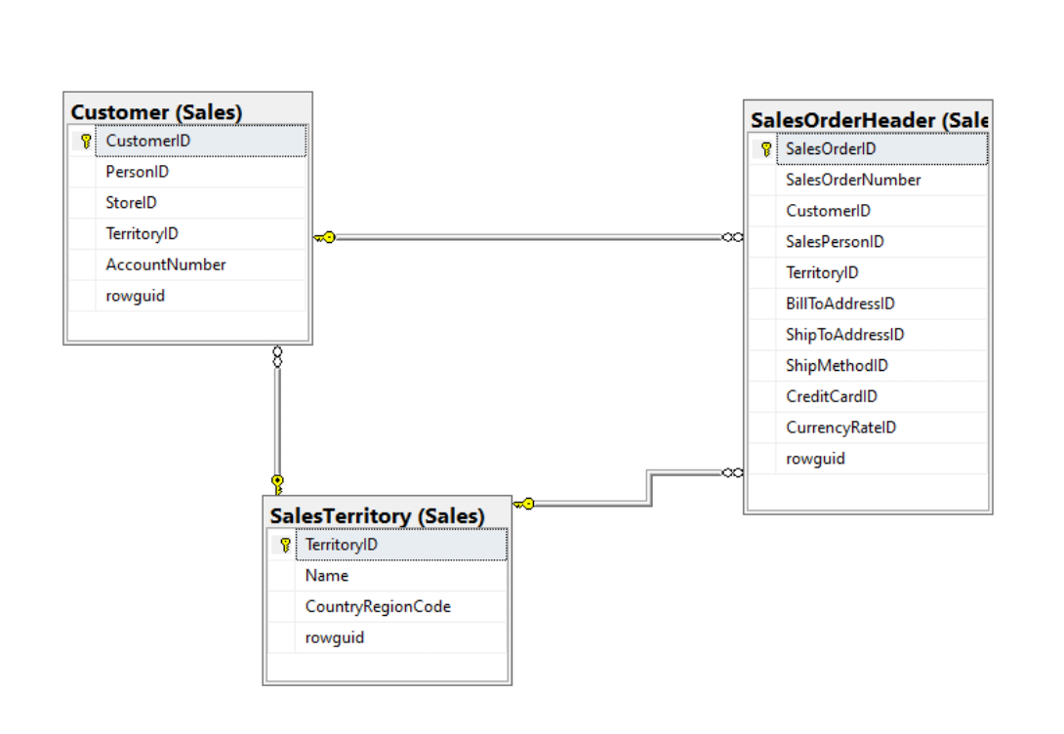

## Standard View:

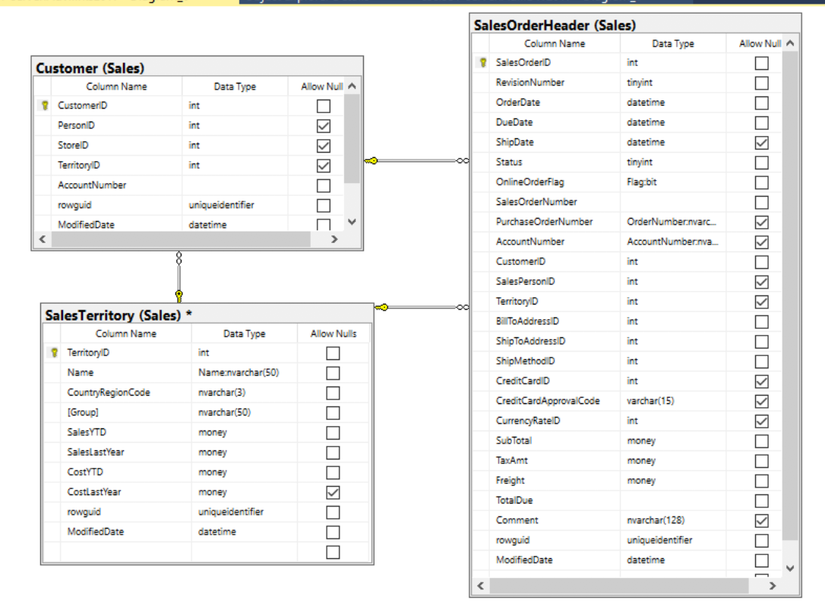

## Code:

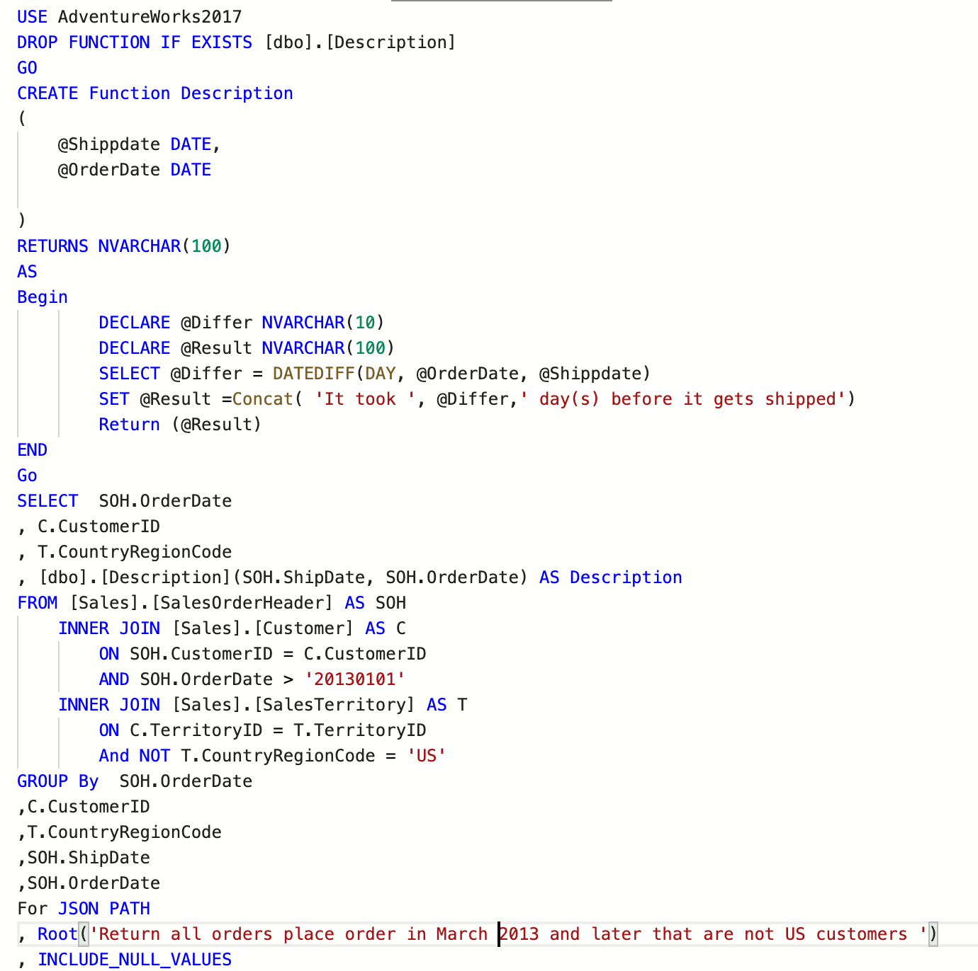

## 

## JSON Path:

## 

## Result Table:

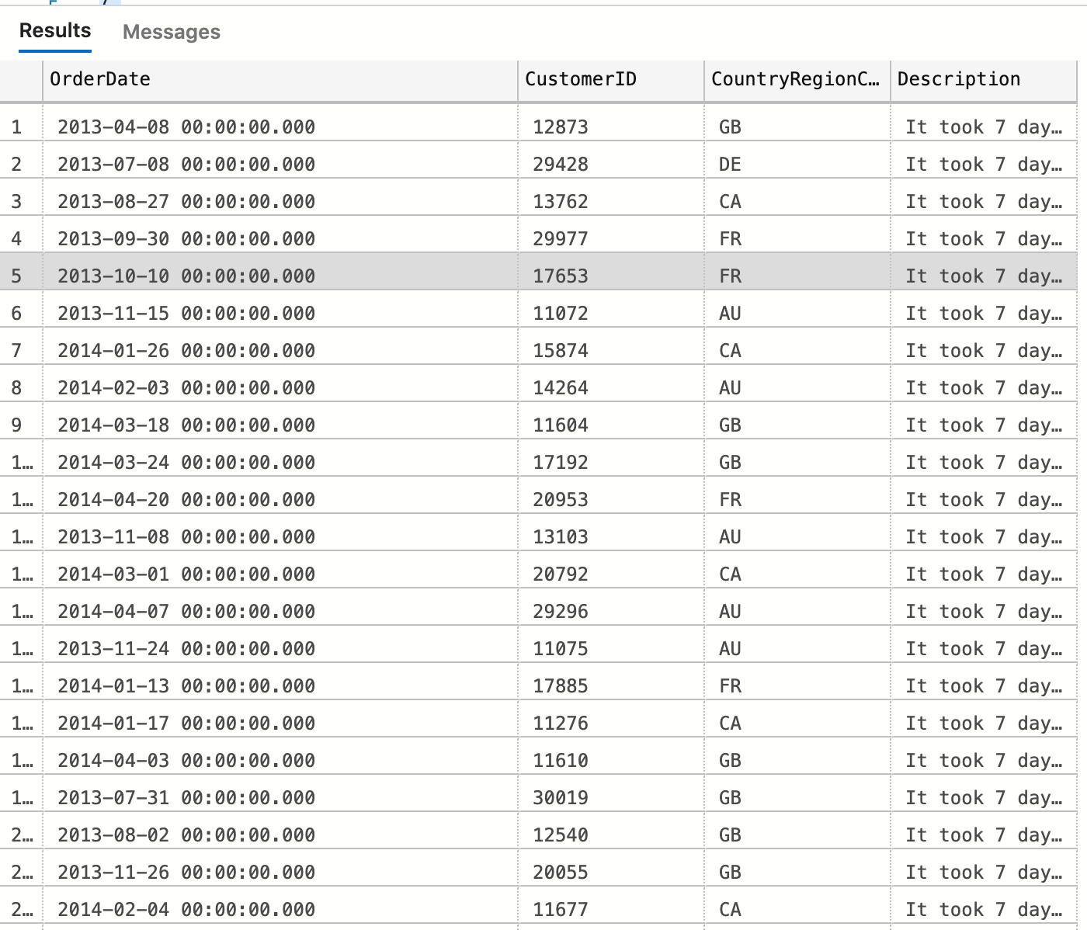

(16265 rows affected)

## Required Table:

|  |  |
| --- | --- |
| Table Name | Column Name |
| Sales.Customer | **CustomerID** |
| Sales.OrderHeader | **OrderDate** |
| Sales.SalesTerritory | **CountryRegionCode** |
| Derived Column | **Description** |

# Complex Problem 4

**Proposition:** Return how many US employees are in a particular gender that has bonus above $2000

**Query Required:** Adventure Works 2017

**Table Required**: Sales.SalesTerritory ,Sales.SalesPerson, HumanResource.Employee

**Problem Description:**

Create a scalar function that takes in two values which are employee’s bonus and gender. It returns the a string stating how much a particular gender’s bonus are.

Create a query that return how many US employees are in a particular gender that has bonus above $2000. List all the genders of all employees, how many employees are in a particular gender and have a call to your scalar function to generate the sum of bonus for each gender. Perform 2 join with Sales.SalesTerritory, Sales.SalesPerson, and HumanResource.Employee and use AdventureWork2017.

## Key View:

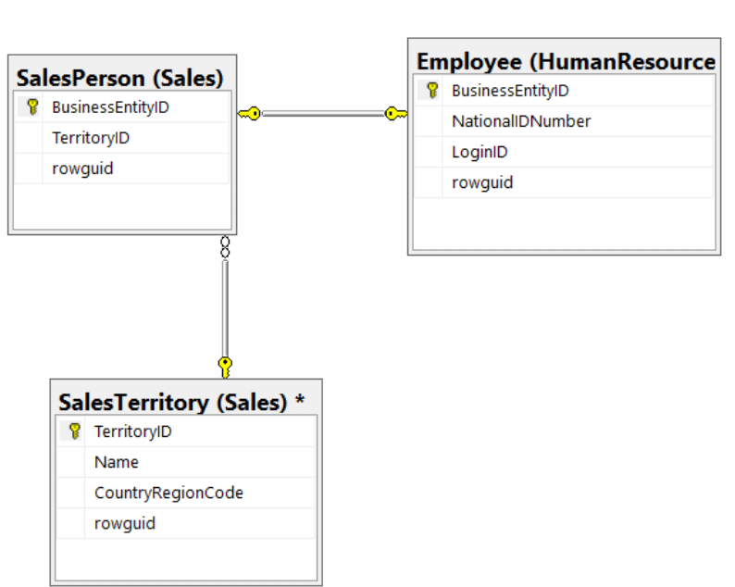

## Standard View:

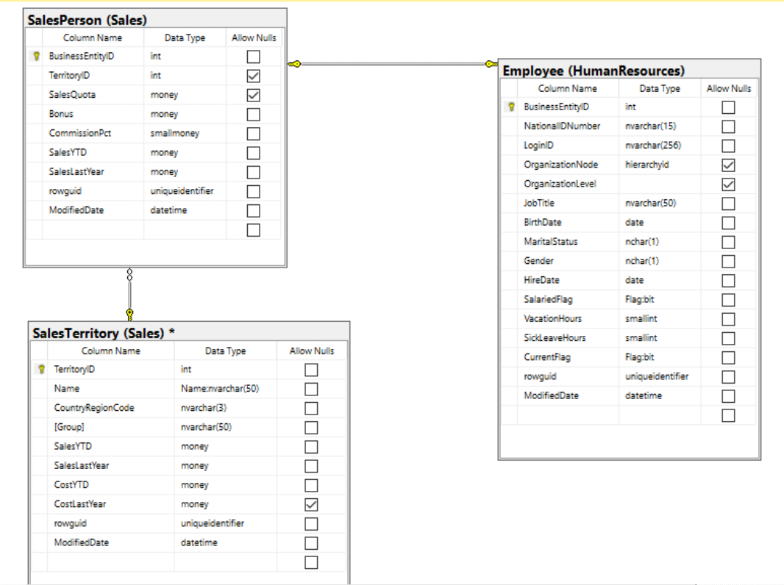

## 

## Code:

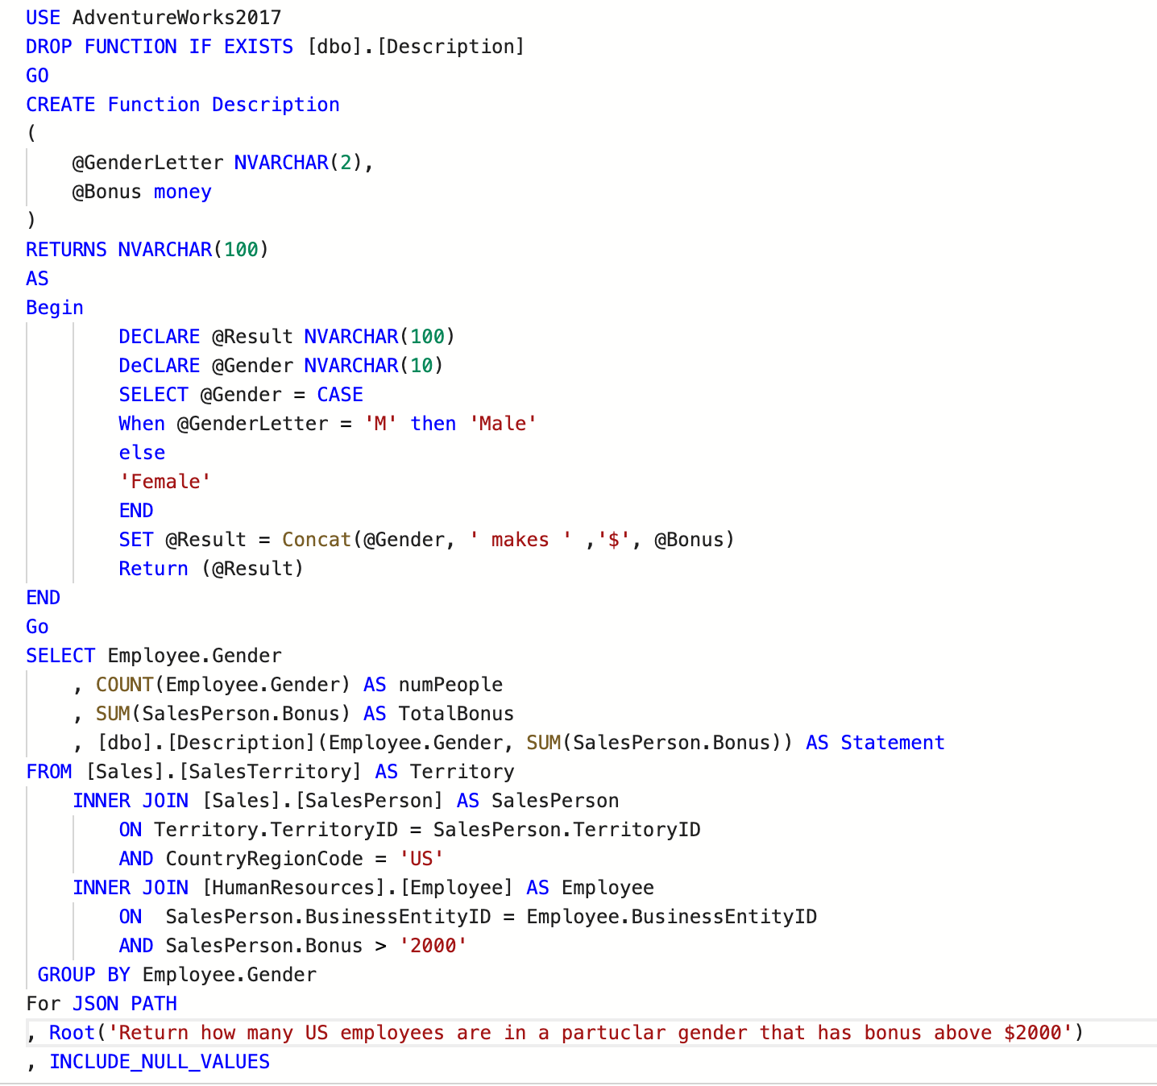

## JSON Path:

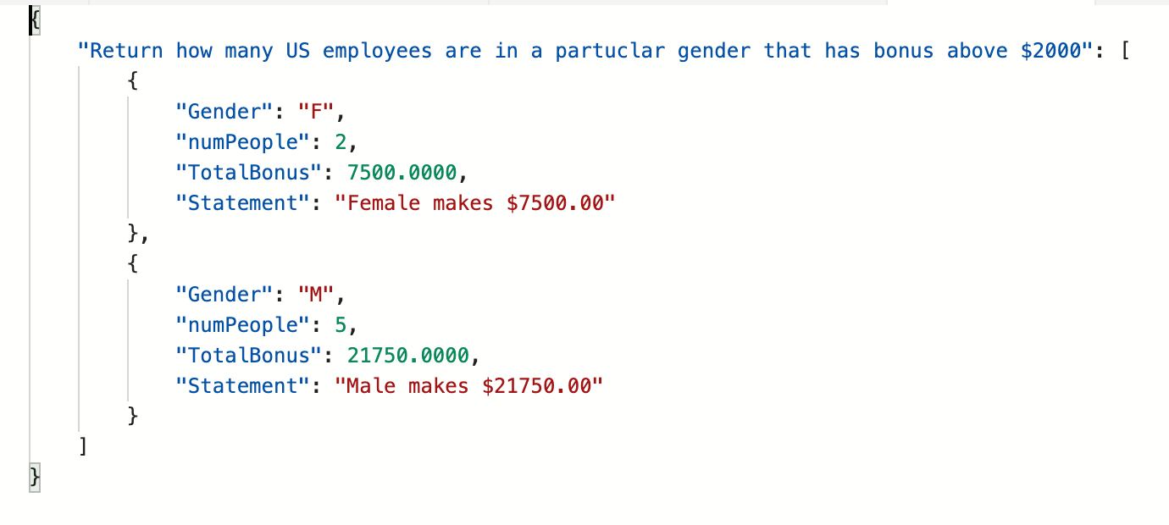

## Result Table:

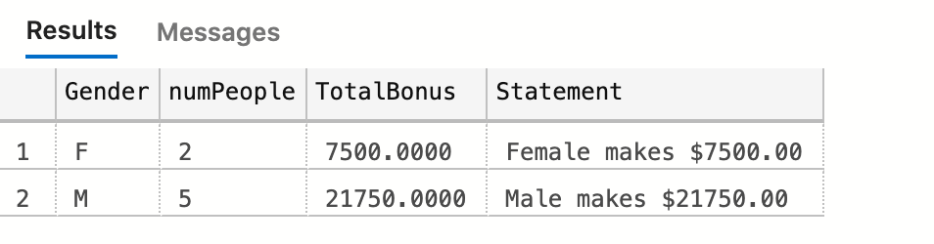

(2 rows affected)

## Required Table:

|  |  |
| --- | --- |
| Table Name | Column Name |
| HumanResource.Employee | Gender |
| Sales.SalesPerson | N/A |
| Sales.SalesTerritory | N/A |
| Derived Column | numPeople  Statement |

# Complex Problem 5

**Proposition:** return all survey responses of those people who pick clothing as their response, by gender and the article of clothing they picked

**Query Required:** Adventure Works DW2017

**Table Required:** dbo.DimProductSubCategory, dbo.DimProductSubCategory, dbo.FactSurveyResponse

**Problem Description:**

Create a scalar function called Description that takes the people’s gender, article of clothing they picked in survey, and number of people who picked that particular article clothing. It then returns a statement as varchar and returns a statement stating number people in particular gender picked the particular clothing.

Create a query that return all survey responses of those people who pick clothing as their response, by gender and the article of clothing they picked. List all the people’s survey response by gender , number of people in the gender that picked the article of clothing, what article of clothing and summary which calls on the scalar function to get the summary. Perform 2 join with dbo.DimProductSubCategory, dbo.DimProductSubCategory, and dbo.FactSurveyResponse and use AdventureWorkDW2017.

## Key View:

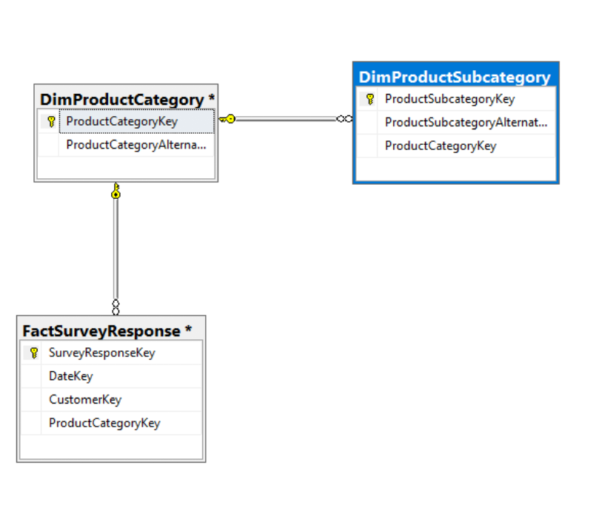

## Standard View:

## 

## 

## Code:

## 

## JSON Path:

## 

## Result Table:

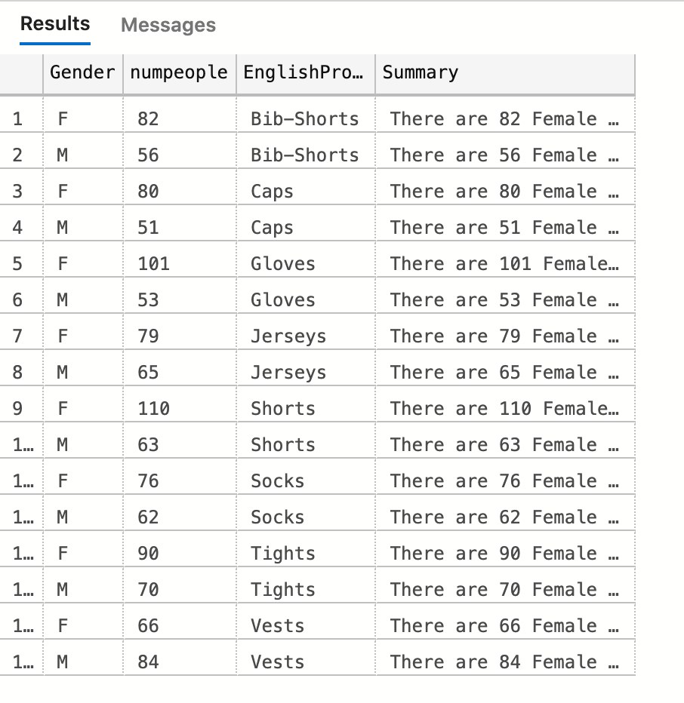

(16 rows affected)

## Required Table:

|  |  |
| --- | --- |
| Table Name | Column Name |
| dbo.FactSurveyResponse | **N/A** |
| dbo.DimProductSubCategory | **EnglishProductSubCategoryName** |
| dbo.DimCustomer | **Gender** |
| Derived Column | **Summary**  **numPeople** |

# Complex Problem 6

**Proposition:** return all the reseller information such as business type, number of reseller and location of the location where the order date in the year 2011 and in Canada

**Query Required:** Adventure Works DW2017

**Table Required:** dbo.DimGeorgarphy, dbo.FactResellerSale, dbo.DiMReseller

**Problem Description:**

Create a scalar function called description that returns a NVARCHAR that returns a sentence about where the type of business is located in Canada. It takes in two parameters province name and the business type.

Create a query that return all the reseller information such as business type, number of reseller and location of the location where the order date in the year 2011 and in Canada. List all the business type, number of business in the area where order date is in 2011 and description which calls the scalar function to produce the statement “The (business type) is located in (province name) , Cananda”. Perform 2 join withdbo.DimGeorgarphy, dbo.FactResellerSale, dbo.DiMReseller FactSurveyResponse and use AdventureWorkDW2017.

## Key View:

## 

## Standard View:

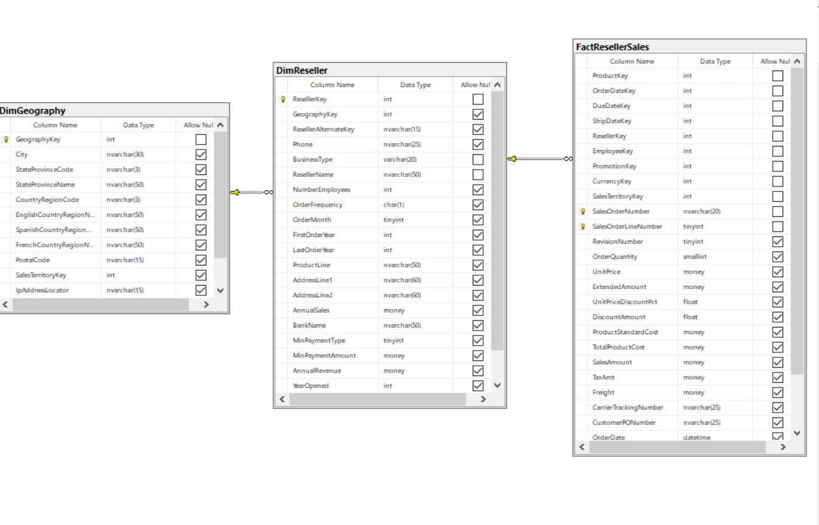

## Code:

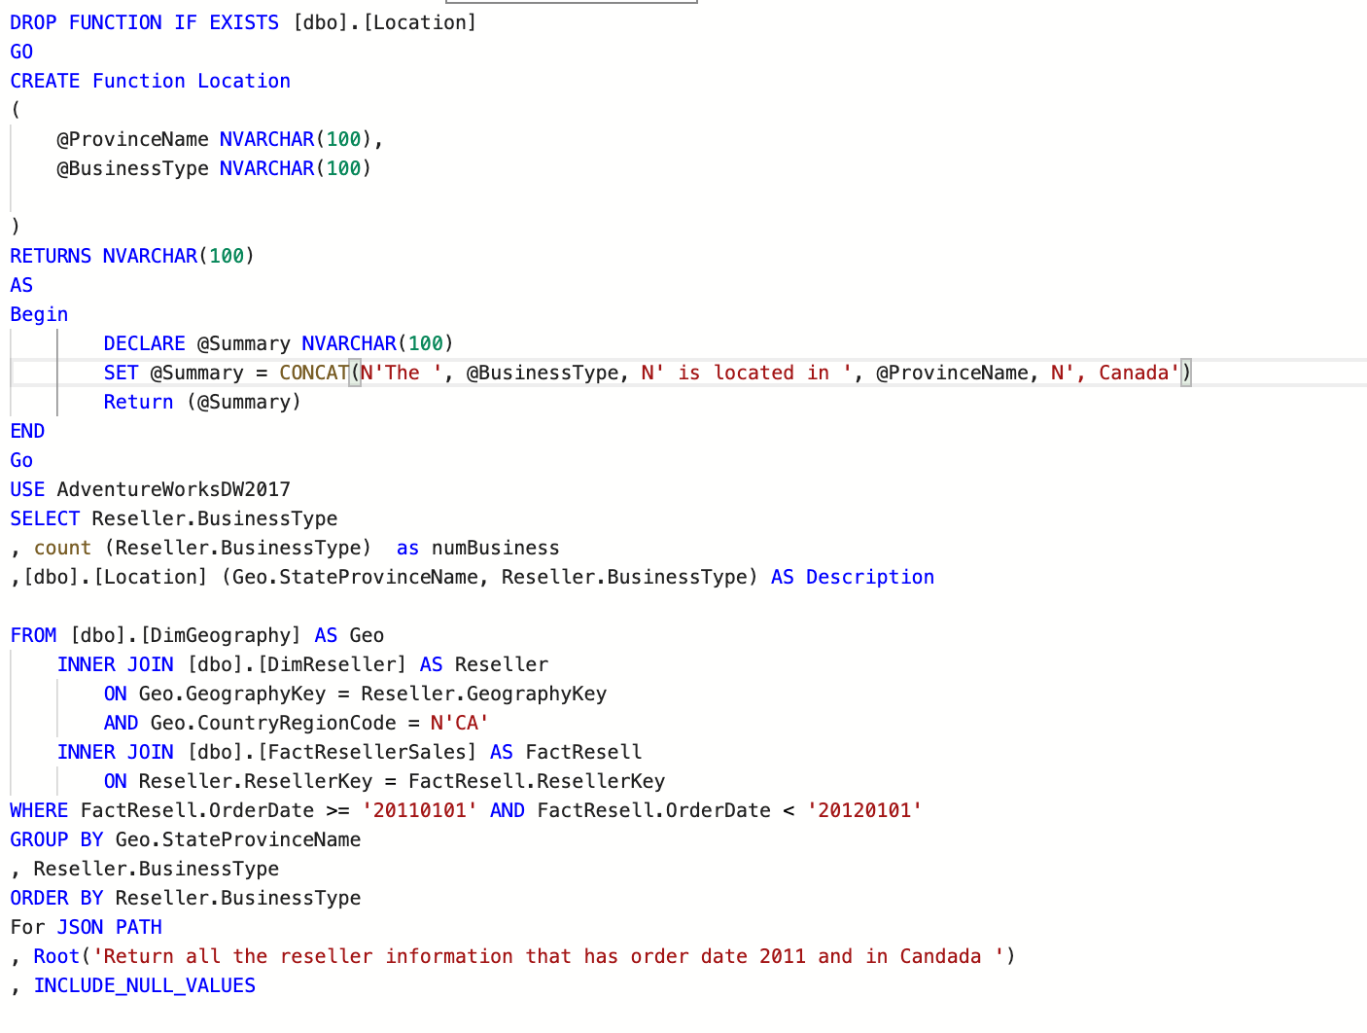

## JSON Path:

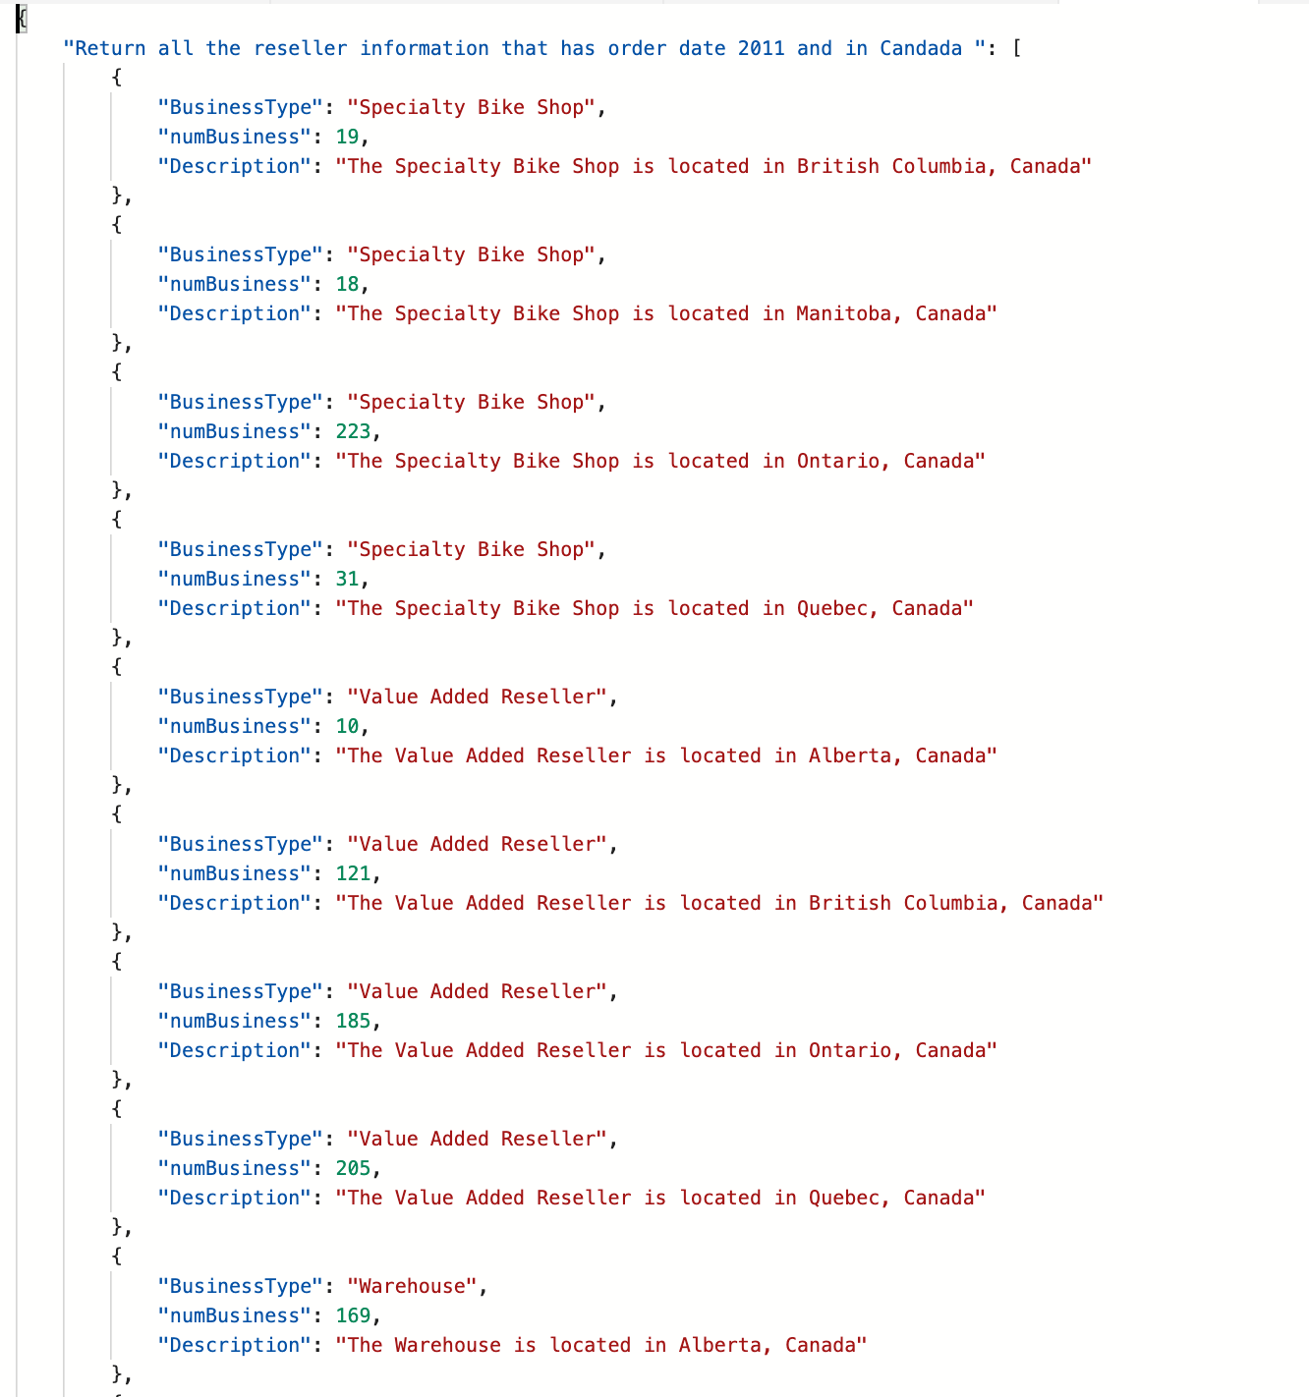

## Result Table:

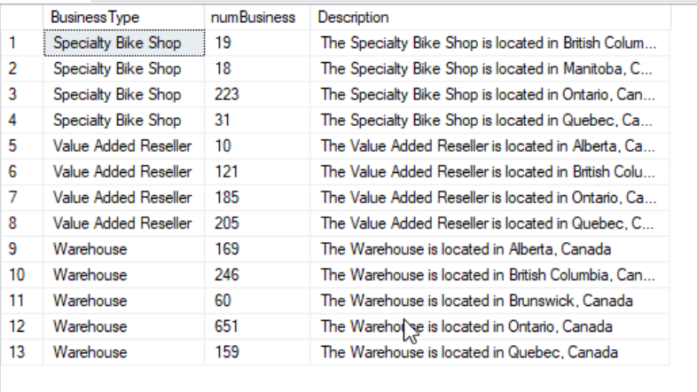

## Required Table:

|  |  |
| --- | --- |
| Table Name | Column Name |
| dbo.DinReseller | **BusinessType** |
| dbo.FactResellerSale | **N/A** |
| dbo.DimGeorgarphy | **N/A** |
| Derived Column | **Description**  **numBusiness** |

# Complex Problem 7

**Proposition:** return sum of  total cost, sum of standard cost and other cost (difference between total and standard cost) where the product that’s ordered  is the minimum order date  and the othercost must be not equal to than zero.be greater than zero

**Query Required:** Adventure Works DW2017

**Table Required:** dbo.FactResellerSales, dbo.DimEmployee, dbo.DimProduct

**Problem Description:**

Create a scalar function that takes sum total cost and sum of standard cost as input and returns other cost that has value of money.

Create a query that return sum of total cost, sum of standard cost and other cost (difference between total and standard cost) for all orders done on the minimum order date and that the other cost is not equal to zero. List all Product Key number of orders, last name, and first name of employee who done the orders,

sum of total cost, sum of standard cost and other cost which calls on scalar function OtherCost. Perform 2 join withdbo.FactResellerSales, dbo.DimEmployee, and dbo.DimProduct and use AdventureWorkDW2017.

## Key View:

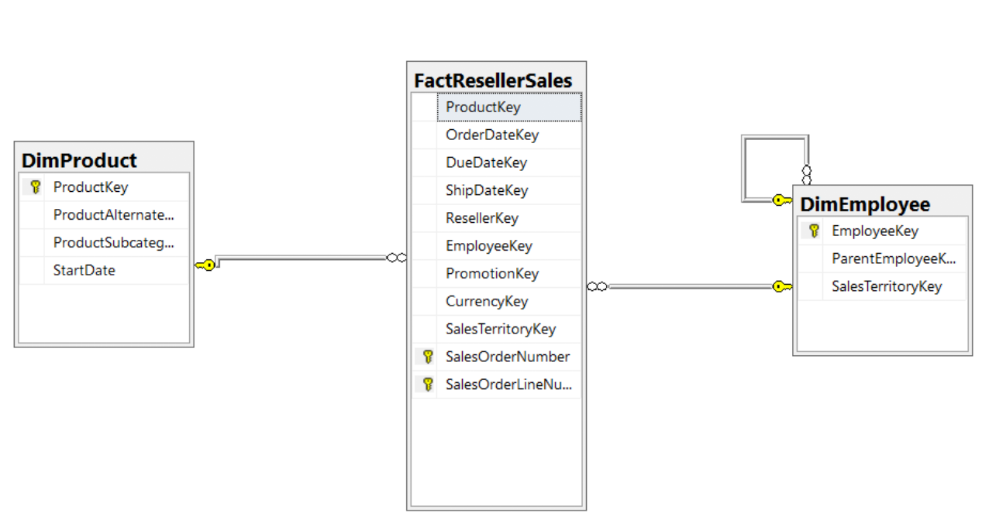

## Standard View:

## 

## Code:

## 

## JSON Path:

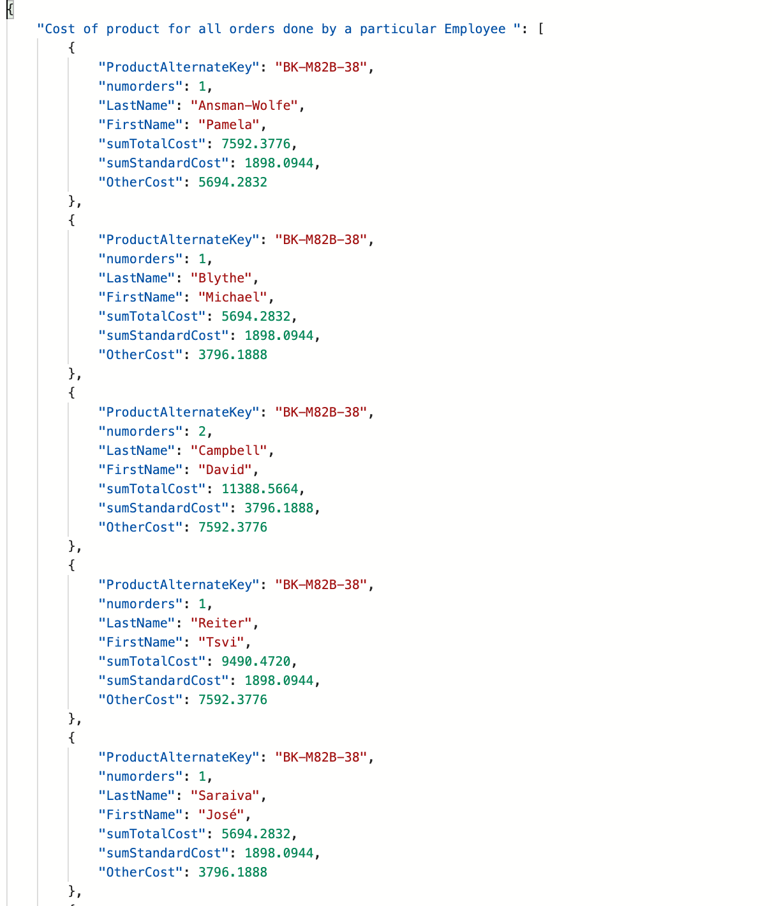

## Result Table:

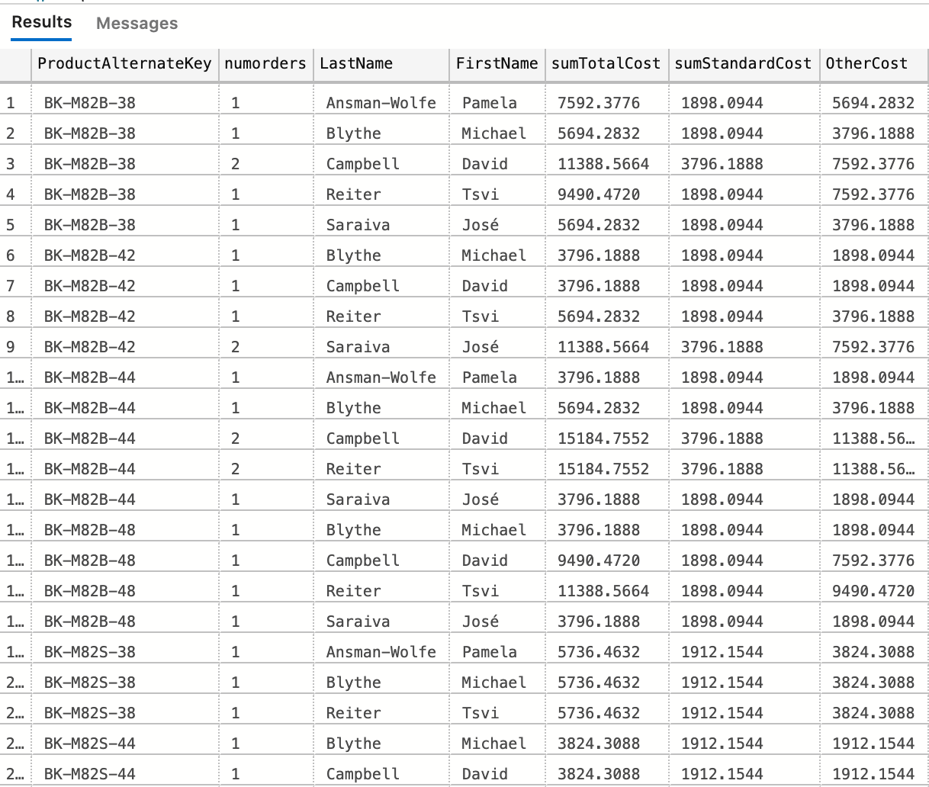

(159 rows affected)

## Required Table:

|  |  |
| --- | --- |
| Table Name | Column Name |
| dbo.FactResellerSales | **LastName**  **FirstName** |
| dbo.DimProduct | **Product AlternateKey** |
| Dbo.DimEmployee | **N/A** |
| Derived Column | **numorders**  **sumTotalCost**  **sumStandardCost**  **OtherCost** |